**Bi-2212 Coil Technology**

Trociewitz, U.P., Hilton, D.K., Kim, Y., Bosque, E., Davis, D., Jiang, J., Hellstrom, E.E., Lu, J., Levitan, J., English, L., Miller, G.E., Larbalestier, D.C. (NHMFL0; Shen, T. (LBNL)

**Introduction**

There are two major pushes for the application of Bi-2212 round wire in the next generation of high field magnet systems: Accelerator magnets for the HEP community, like advanced dipoles made with Rutherford cables, and solenoids for NMR. The development of high field HTS dipole magnets in the US is centered at the LBNL, lead by T. Shen, with whom we collaborate on the coil heat treatment issues. Our focus at the NHMFL is the development of high field nuclear magnetic resonance (NMR) magnets beyond 30 T (1 GHz) using HTS. We are in the process of building a layer-wound, round-wire, Bi-2212 insert magnet (“Platypus-2”), which in combination with our 16.5 T low temperature superconducting (LTS) outsert magnet is expected to approach 1 GHz. The NHMFL’s purchase of a high pressure furnace in which Bi-2212 coils can now be processed to achieve excellent and reproducible transport properties, has enabled systematic R&D work on Bi-2212 wire for superconducting high field magnet applications.

**Experimental**

Mechanically Bi-2212 wire can be best compared with Nb3Sn wire: to understand how this wire should be used in high field magnets we made a series of test-coils and models particularly focusing on the challenge of mechanical reinforcement. At LBNL dipole magnets using Bi-2212 Rutherford cable were made and tested. These magnets were over pressure heat treated (OPHT) at the NHMFL.

**Results and Discussion**

After changing our conductor insulation approach, all of the recently made Bi-2212 solenoids were without electrical shorts between windings after the OPHT. In in-field tests up to 8 T, the coils showed small hysteresis (± 1 mT to ± 5 mT) and the coils rapidly responded to change of the operation current. Without any reinforcement the coil of Fig. 1 would have experienced a maximum hoop stress of about 300 MPa, about twice the wire failure stress. Performance envelopes created by FEA models, predicted 348 A for the onset of damage and an actual trip was observed at 350 A, a good match between model and experiment that validates the implemented coil reinforcement strategies. Below the onset of thermal runaway, the coils could be load-cycled many times without any signs of coil degradation. A Platypus-2 model coil with several turns of Bi-2212 wire and thermal mass equivalents distributed at critical locations was made and given a full OP HT. Transport data from wire samples indicated that the proper tuning of the furnace required for the actual Platypus-2 heat treatment was achieved, Fig. 2. LBNL’s race track coils that we OPHTed in our furnace showed *Ic* of 8.2 kA in tests at LBNL. This is a fourfold increase over LBNL’s race track coils heat treated at 1 bar and a significant step forward in advanced dipole technology. For the first time LBNL used our TiO2 coating on their Rutherford cables and a significant reduction of conductor leakage was observed, Fig. 3.

Fig. 1: Test coil “Riky-3” and predicted coil performance envelope of three Riky-type test coils with various amount of reinforcement.



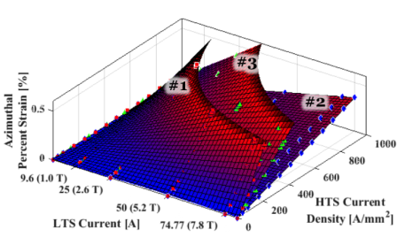

Fig. 2: Sample *Ic* and Platypus-2 model coil with several turns of Bi-2212 wire and thermal mass equivalents (stack of Inconel rings).



**. . . .**

**Leakage spots**

Fig. 3: Alumino-silicate braided race track coils RC-1 (left) and RC-3 (right). A clear difference can be seen in the amount of leakage between RC-1 without and RC-3 with the TiO2 coating.

**Acknowledgements**

This work is supported by the National Science Foundation under DMR-1157490, by the State of Florida and by a grant from the National Institute of Health under 1 R21 GM111302-01.