Transport critical currents at variable temperatures and field orientations for 7.5% and 15% Zr doped R&D ReBCO measured up to 45T

Abraimov, D., Constantinescu, A., Jaroszynski, J. (ASC, NHMFL); Zhang, Y. (SuperPower Inc.); Hahn, S., Larbalestier, D.C. (ASC, NHMFL)

Introduction
ReBCO superconductors have become a choice material for developing all superconducting magnets capable generating ultra-high fields due to very high critical current densities in the presence of magnetic fields and high irreversibility fields. The understanding performance of APC at fields above 20T fields is important for solving vortex dynamics problems, conductor development, and magnet design.

Experimental
Ultra narrow bridges were prepared from R&D ReBCO with 7.5% and 15% Zr doping tapes produced by SuperPower Inc. Bridges were patterned with optical photolithography, wet etching, and trimmed with FIB to 1.6 – 4.6 um width. Due to exceptionally high ReBCO uniformity, we were able to prepare 63-127 um long bridges suitable for transport measurements. Above 4.2K I-V curves were measured in He gas. For highest currents, I-V curves were measured using pulsed technique to avoid overheating. Transport critical currents were measured at variable temperatures (4.2K-30K) and field orientations at <E>=10 μV/cm criterion in NHMFL Hybrid DC magnet up to 45T in a specially dedicated new probe.

Results and Discussion
At 10K and 20K and fields above 20T in BIItape orientation we detected that J_{c} is field independent within the accuracy of the experiment (see Fig.1(a)). As we expected at 42T J_{c}(θ, 4.2K)15% Zr ReBCO has wider ab-peak, however slightly lower peak value. Full width half maximum for 7.5% Zr doping is 10.5º and 29.7º for 15% Zr (see Fig.1(b)). Near B⊥tape J_{c} values match. Shown in Fig.1(c) J_{c}(B,T) dependence at B⊥tape orientation is linear in log-log scale up to 45T, but J_{c} drops faster with field above 20K. At 4.2K we did not observed decrease of pinning force density F_{p} above 30T; at 12T F_{p} maximum is at 25T for 7.5%Zr tapes. Critical currents follow well dependence I_{c}(B,T)=I_{co}(B)exp(-T/T_{o}). We found lower T_{o} values for tapes with 15% Zr.
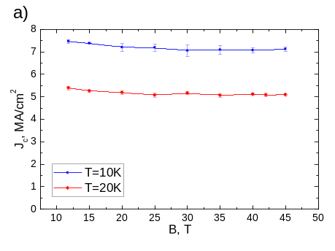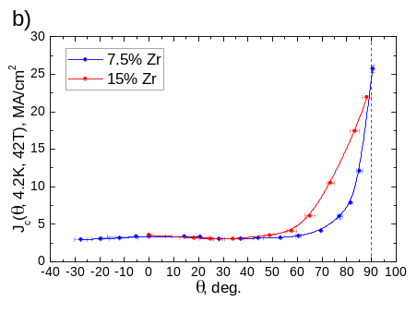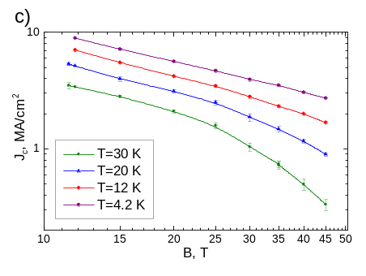
Fig.1 (a) Field dependence of J_{c} at BIItape up to 45T at 10K and 20K for ReBCO with 7.5% Zr. (b) Comparison of J_{c}(, 4.2K, 42T) for two ReBCO bridges: 7.5% and 15% Zr doping. (c) J_{c} (B,T) at B⊥tape for ReBCO with 7.5% Zr, doping covered with original Ag. Bridge dimensions: W=4.6m, L=105.6m, ReBCO thickness t=1.22 m.
Conclusions
We have shown that measurements of transport I_{c}(θ, B, T) of modern high J_{c} R&D ReBCO tapes is possible up to 45T. We confirmed experimentally that J_{c} does not drop in high fields at BIItape, which is desired result for magnet applications. Critical currents of tapes with 15% Zr doping decrease faster with temperature than 7.5% Zr. However, critical currents for tapes with higher Zr doping are less anisotropic even at fields above 30T.

Acknowledgements
This work was supported in part by the U.S. National Science Foundation under Grant No. DMR-0654118,
DMR-0923070 and the State of Florida. A portion of this work was performed at the National High Magnetic Field Laboratory, which is supported by National Science Foundation Cooperative Agreement No. DMR-1157490 and the State of Florida.

