Variable Temperature Transport Current Measurements on ReBCO Coated Conductors

Francis, A.; Abraimov, D.; Viouchkov, Y.; Larbalestier, D.C. (NHMFL, FSU)

Introduction
Transport current measurements are essential in the design of magnet systems. A wide variety of ReBCO tapes are currently available from multiple suppliers. Critical current characterization of these at varying temperatures allows for tape selection and accurate modeling of quench behavior in REBCO magnets.

Experimental
We studied ReBCO coated conductors purchased from SuperPower Inc. for use in the 32T user NHMFL magnet system. Utilizing and developing a technique described in Ref.1, a new user-friendly probe was designed to allow I_{c}(B,T) on 4mm wide tapes up to 700A currents with a standard 15 T, 52 mm bore Oxford Instruments superconducting magnet system. To allow accurate modeling of the 32 T magnet quench, we measured three typical tapes used for the 32T project: low I_{c}, midrange I_{c}, and high I_{c}. Each tape was measured at temperatures from 4.2K to 75K and fields ranging from 1T to 15T in B⊥ tape orientation. For currents over 200 A, pulsed currents were used to prevent overheating.
$$I_{c}(B, T)=I_{c*}B^{-α}exp\left(-T/{T_{o}}\right)$$ | (1)
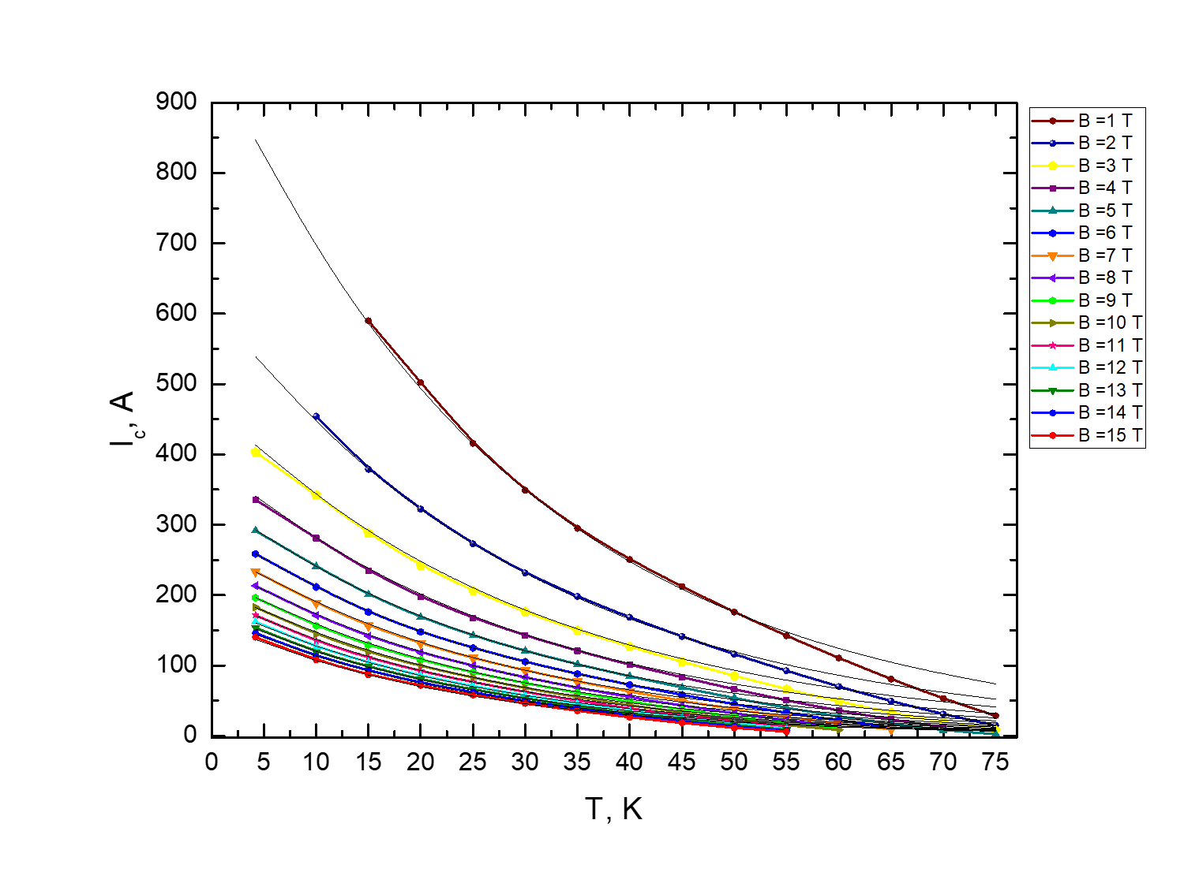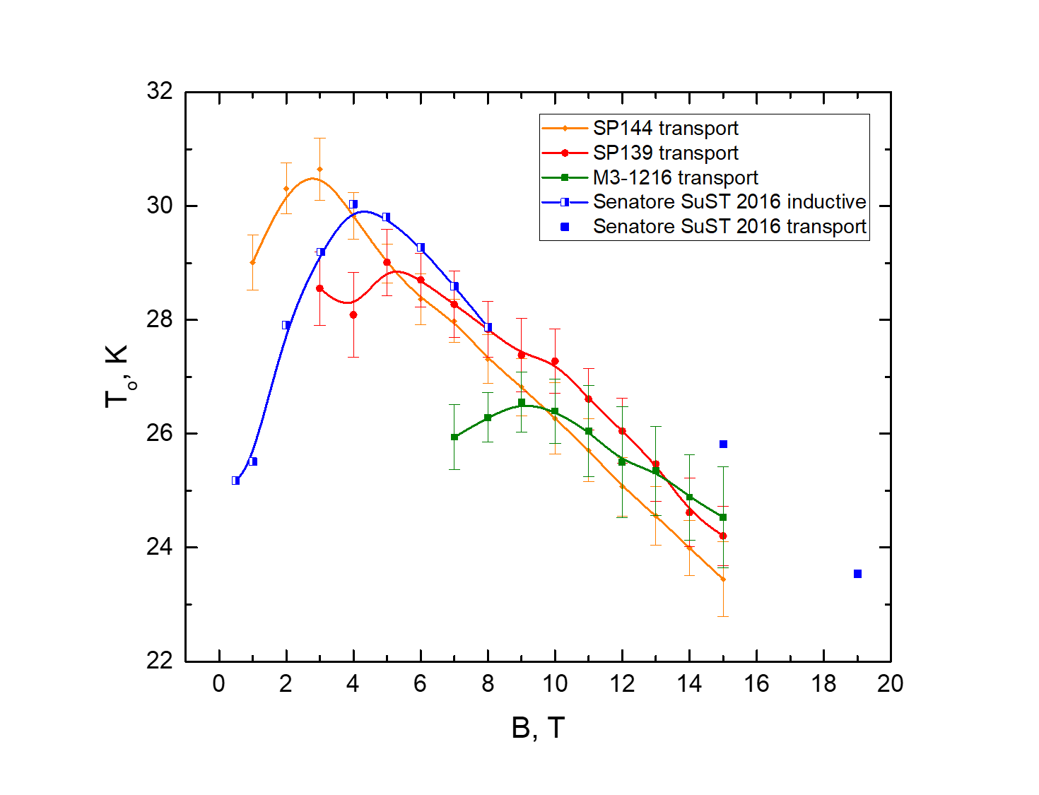
Fig.1 (Left) Transport I_{c}(B,T) at B⊥ tape orientation for SP144 SuperPower 4 mm wide tape measured in
OX III with new variable temperature probe. Fitted curves are matching well with experimental data at T<45K.
(Right) Magnetic field dependence of fitting parameter T_{o}(B) compared with data from C. Senatore et al. paper [3].

Results and Discussion
The I_{c}(B,T) dependencies were fitted with equation (1) from Ref. 2 and fitting parameters T_{o}, I_{c*} were found for each tape (see Fig.1 (Left)). For all measured samples I_{c}(B,T) followed well the dependence (1). After the maximum value, T_{o}(B) monotonically decreases with the field (Fig.1 (Right)). Tapes with different I_{c} have different T_{o max}. For R&D tape T_{o}-B slope is smaller than for production line tapes. The position of maximum in T_{o}(B) graph correlates with BZO density. Tape with smallest BZO density (and therefore smallest in-field I_{c}) SP144 has the largest T_{o max} showing at low field B=2.8T. T_{o} maximum shifts to higher fields for tapes with higher BZO density.

Conclusions
We succeeded in measuring I_{c}(B,T) on full-width modern ReBCO tapes, an important part of the quench modelling by Andy Davrilin. The fitting parameter T_{o} is in good agreement with data obtained by another group [3]. We plan to use correlations between fitting parameters of extensive I_{c}(B,T) data set, and I_{c}(4.2K,B) data to predict I_{c}(B, T) for any tapes purchased for magnets beyond 32T.

Acknowledgements
This work was supported in part by the U.S. National Science Foundation under Grant No. DMR-0654118,
DMR-0923070 and the State of Florida.

References
[1] Godeke, ten Haken, ten Kate, IEEE Trans. Appl. Supercond. 9 161 (1999)
[2] G. Blatter, et al., Rev. Mod. Phys., 66, no. 4, 1125–1388 (1994);
[3] Senatore, C., et al., Superconductor Science and Technology, 29 (1), 014002 (2015).

