Comparison of a-axis Grain Growth in Multifilamentary Bi-2212 Round Wires with Different Critical Current Densities

Oloye, T.A., Kametani, F., Matras, M., Jiang, J., Hellstrom, E.E. and Larbalestier, D.C. (NHMFL)

Introduction
In order to develop high critical current density Jc in long-length high temperature superconducting (HTS) wires, it is necessary to avoid deleterious grain boundaries (GBs). Bi-2212 round wires are unique with regard to the grain texturing that occurs, despite their round wire architectures. In fact a unique grain texture of Bi-2212 is developed by the strong a-axis grain growth along the narrow filament cavities. In the over pressure (OP) heat treatment process, controlling the Bi-2212 a-axis grain growth is the one of key factors for high J_{c}. Yet it is not fully understood how the heat treatment parameters, or the quality of precursor powder play roles for such grain texturing.

Experimental
In order to evaluate how these parameters affect the Bi-2212 a-axis texture, we compared the transverse cross sections of filaments in three Bi-2212 wires with significantly different J_{c} values, all heat treated at 50bar over-pressure. Table 1 provides heat treatment parameters and their resulting J_{c} values. The two lower J_{c} samples (sample a and b, respectively) used the NEXANS precursor powder, while the highest Jc sample used a finer-particle powder from nGimat. These samples were polished in a JEOL Cross Section Polisher (CSP) using an Ar ion beam at 6kV for 6 hours to expose their transverse cross sections. The filament cross sections were then investigated by Electron Backscatter Diffraction-Orientation Imaging Microscopy (EBSD-OIM) in a Carl Zeiss 1540EsB Scanning Electron Microscope.

Results and Discussion
Figure 1 shows the Inverse Pole Figure (IPF) maps of the three Bi-2212 wires a, b and c. Figure 1a and b suggest that a slow cooling rate (R_{F} = 1.3 °C/h) promotes a large 2212 grain size, resulting in ~23% J_{c} increase in sample (b) compared to fast cooled (R_{F} = 8.0 °C/h) sample (a). Sample (a) also has thinner Bi-2212 grains than the others. In contrast, sample (c) made with nGimat powder developed the highest J_{c} (as of Dec. 2017) with grains aligned along the [100] direction. Interestingly these high J_{c} Bi-2212 grains have a similar diameter, but they are twice as thick as those in the lowest J_{c} sample (a). Since the highest J_{c} sample uses the new nGimat powder, not the older NEXANS powder, we can directly correlate these microstructural differences to the different heat treatment parameters. Further detailed studies of a-axis growth texture on the longitudinal cross sections will be interesting.
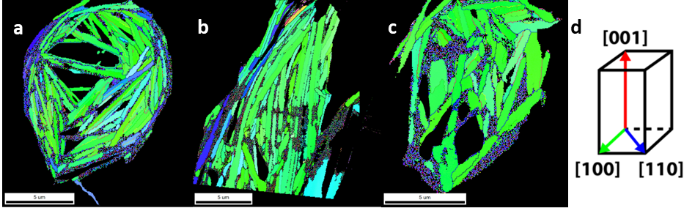
Fig. 1 Inverse Pole Figure (IPF) maps of 3 bi-2212 wires with different heat treatment parameters and different Jc values. Note that the secondary 2201 phases and Ag phases have been blacked out
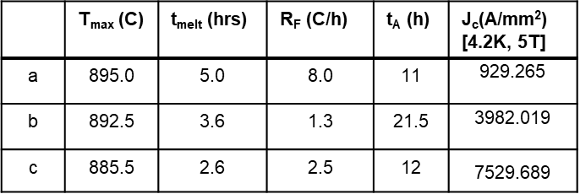
Table I Heat treatment parameters and Ic values for
Bi-2212 wires used in this study
Conclusions
Microstructural analysis of Bi-2212 wires heat treated with different heat treatment parameters or with different powders, suggested that these parameters have a direct bearing on the size and misorientation direction of 2212 grains on the transverse cross section. Future work aims to study the longitudinal cross section of these wires, to enable a clearer picture of how exactly these heat treatment parameters affect grain growth, and subsequently use this information to optimize Ic values.

Acknowledgements
A portion of this work was performed at the National High Magnetic Field Laboratory, which is supported by National Science Foundation Cooperative Agreement No. DMR-1157490 and the State of Florida. The work was supported by the US Department of Energy Physics under DE-SC0010421.

