Electrical performance of CSD YBCO nanocomposites at ultrahigh magnetic fields

Valles, F.; Palau, A. and Puig, T. (ICMAB, CSIC); Abraimov, D., Jaroszynski, J., Constantinescu, A.M. and Larbalestier, D. (ASC, NHMFL)

Introduction
High temperature superconducting films grown by chemical solution deposition (CSD) have become very appealing for the pursuit of successful development of long length superconducting tapes at affordable cost [1]. Recently, there is an increasing demand of ultrahigh fields in high energy physics (mainly led by CERN), opening new challenges for applications with REBCO based superconductors. We have investigated the critical currents at ultrahigh magnetic fields of CSD-YBCO thin and thick films, with and without the inclusion of nanoparticles.

Experimental
Four probe electrical transport measurements were carried out to determine the critical currents of two pristine films (250nm and 700nm thick) and two nanocomposites (with nanoparticle molar concentrations of 20%BaHfO₃ and 20%BaZrO₃, 170nm and 700nm thick respectively). Superconducting films were patterned with standard optical lithography and wet etching, obtaining 20-100 μm wide bridges. J_{c}(B,T,θ) characterization was conducted from 4.2K up to 50K in a tight-vacuum probe with a sample-rotation system, measuring θ from 0º(c-axis) to 90º(ab-planes) in the 35T and 32mm bore magnet in the DC Field facility in Tallahassee.

Results and Discussion
Figure 1(a) depicts the field dependence of Jc at 4.2K and 30K. We observe an enhancement of J_{c} for nanocomposites up to an intersection field B_{int} where curves intersect with pristine films. The power-law exponent α (Jc~B^{-α}) is higher in nanocomposites as confirmed in the report of the experiments realized in 2016. In figure 1(b), we study the angular dependence of J_{c} at 20K at lower (15T) and higher (35T) fields in comparison to the B_{int}. We observe first, that the ab-peak is widened for nanocomposites, in agreement with a higher density of stacking faults emerging from nanoparticles [1]. Jc is improved for all orientations bellow B_{int} whereas it is only improved near ab-planes orientation above B_{int}. In figure 1(c) we have plotted the absolute critical current Ic versus magnetic field for B||c, achieving a big enhancement for the thick nanocomposite.
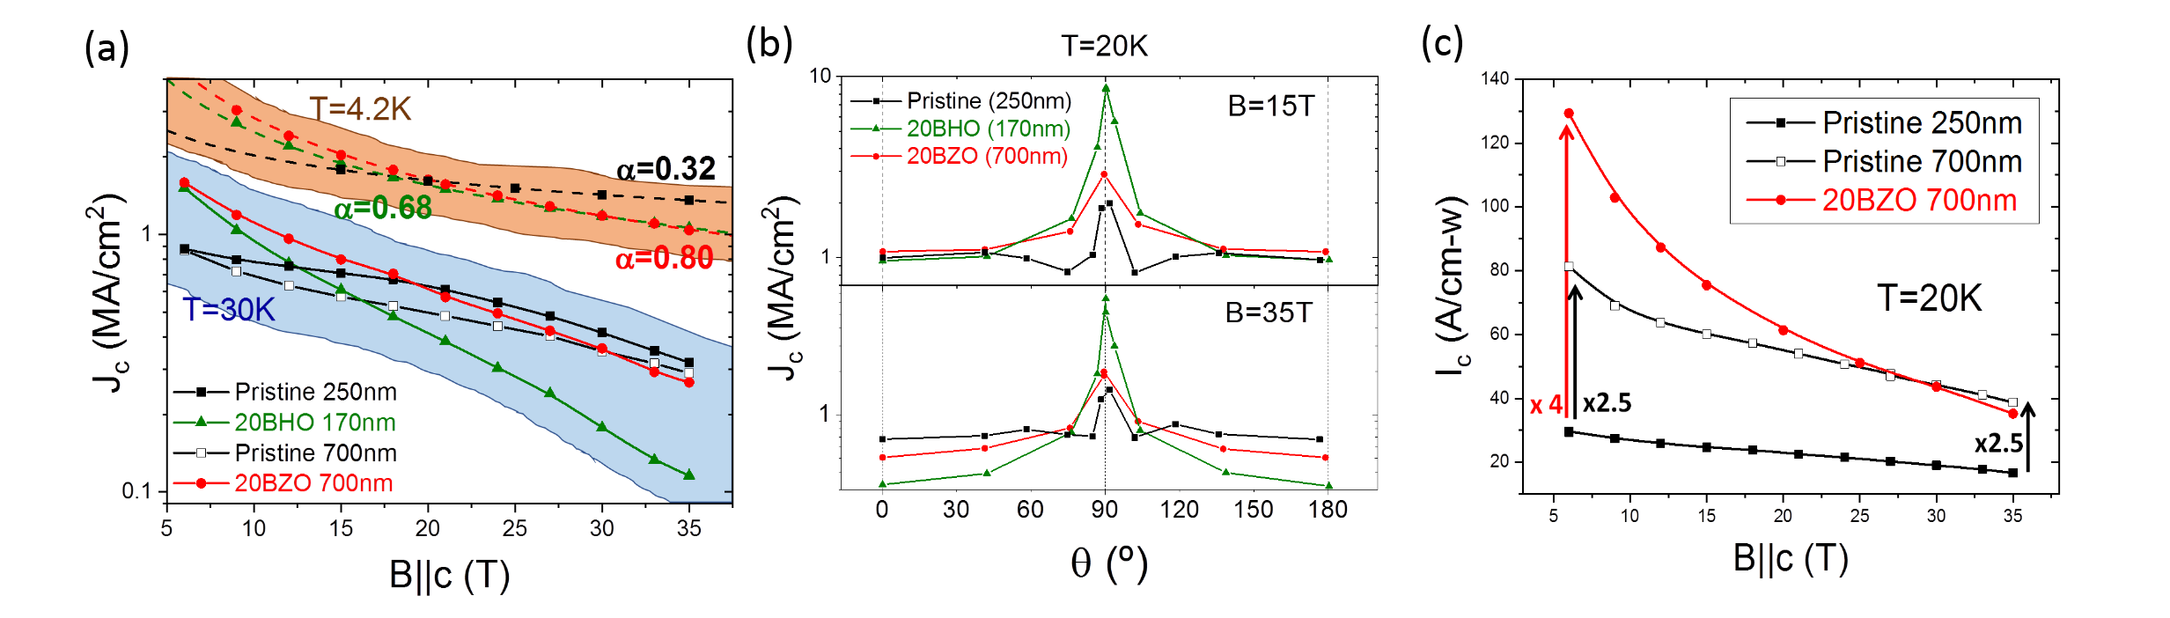
Figure 1. (a) Magnetic field dependence of Jc for B||c at 4.2K and 35K, (b) Angular dependence of Jc at 20K both at 15T and 35T, (c) Magnetic field dependence of Ic at 20K for B||c.

Conclusions
Nanocomposites exhibit enhanced pinning performance up to the intersection field that increases with decreasing temperature. The 20%BaZrO₃ nanocomposite shows best performance in terms of Ic.

Acknowledgements
Part of this work was performed at the National High Magnetic Field Laboratory, which is supported by National Science Foundation Cooperative Agreement No. DMR-1157490 and the State of Florida.
We also acknowledge financial support from the EU-FP7 NMP-LA-2012-280432 EUROTAPES, COST action MP1201, MAT2014-51778-C2-1R and SGR-753 Generalitat de Catalunya.

References
[1] A. Llordés et al., Nature Materials, 11, 329-36 (2012)

