World record pinning force density for Fe-based superconductors

Iida, K., Matsumoto, T., Oomura, T., Hatano, T. and Ikuta, H. (Nagoya Univ.); Tarantini, C. and Jaroszynski, J. (ASC-NHMFL, FSU); Meyer, S., Kauffmann-Weiß, S. and Hänisch, J. (KIT)

Introduction
The transport critical current density, J_{c}, of an oxypnictide epitaxial thin film was measured at 4.2 K as a function of magnetic field and field orientation. Our NdFeAs(O,F) thin film showed a record pinning force density of over 1 TN/m³ at 35 T, which is the highest ever reported for Fe-based superconductors (FBS). This result highlights the potential of possible high-field applications using Fe-based superconductors.

Experimental
The epitaxial NdFeAs(O,F) thin film of 20 nm was grown by molecular beam epitaxy at Nagoya university. For transport measurements, a small bridge of 70 μm width and 1 mm length was prepared by a laser cutter at ASC-NHMFL. DC magnetic fields up to 35 T (at DC facilities at NHMFL) were applied and J_{c} measured in maximum Lorentz force configuration.
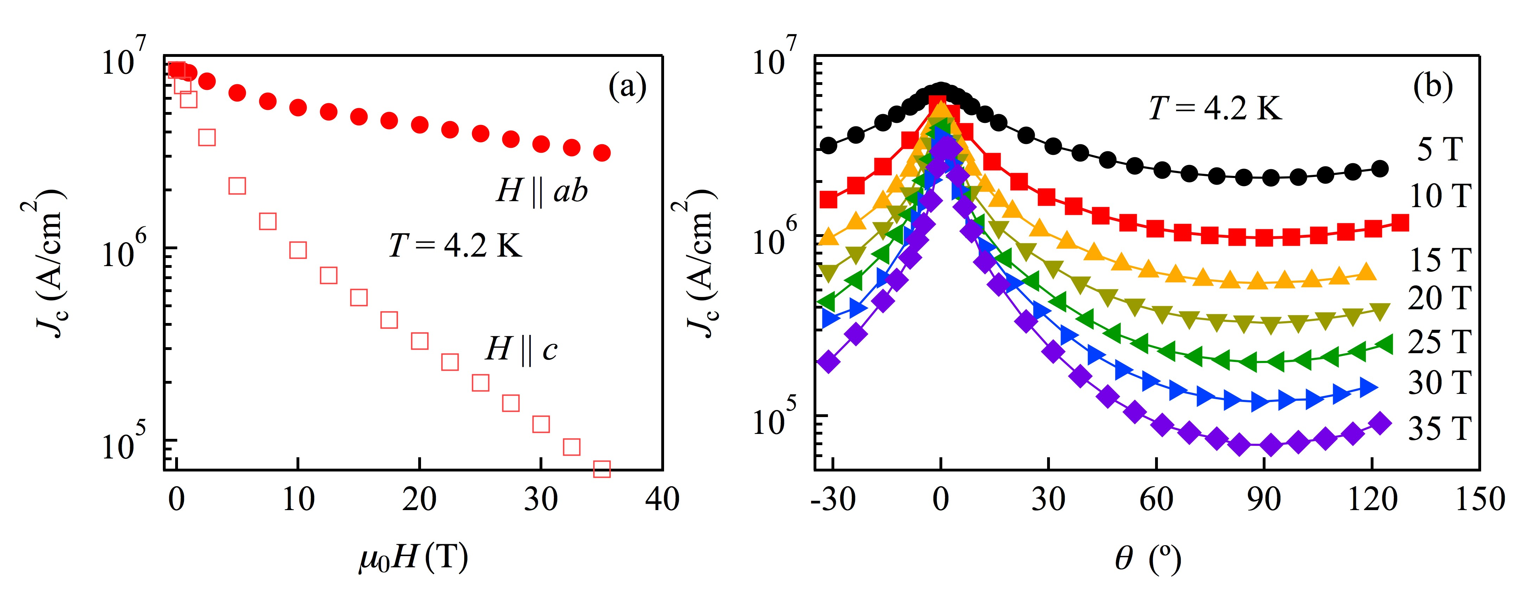
Fig.1 (a) Field and (b) angular dependence of a NdFeAs(O,F) thin film at 4.2 K.
Results and Discussion
Self-field J_{c} of 8.6 MA/ cm² was recorded at 4.2 K. Applying a magnetic field suppresses J_{c} largely for H//c, whereas the J_{c} reduction for H//ab is not so significant (Fig. 1(a)). This indicates anisotropy in physical parameters and/or geometry. Angular dependence of J_{c} showed no sign of c-axis correlated defects (Fig. 1(b)).
Figure 2 compares the pinning force density, F_{p}, for several oxypnictides measured at NHMFL [1-2]. Clearly the present NdFeAs(O,F) thin film showed the highest F_{p} for both crystallographic directions. Note that F_{p} for H//ab does not reach the maximum value even at 35 T. To the best of our knowledge, F_{p} over 1 TN/m³ is the highest value ever reported for FBS.
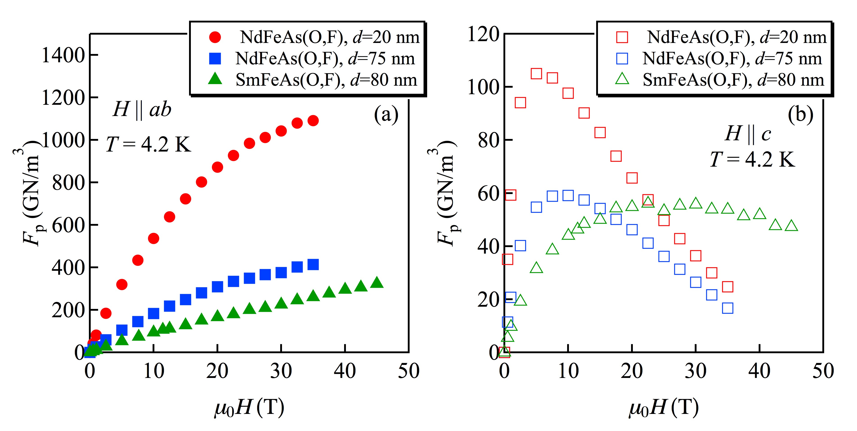
Fig.2 F_{p} for various oxypnictides (a) H//ab and (b) H//c at 4.2 K. The date of SmFeAs(O,F) with d=80 nm and NdFeAs(O,F) with d=75 nm are taken from refs. [1] and [2], respectively.
Conclusions
The results show the potential that FBS could have for high-field applications.

Acknowledgements
A portion of this work was performed at the National High Magnetic Field Laboratory, which is supported by National Science Foundation Cooperative Agreement No. DMR-1157490 and the State of Florida.
The work at Nagoya University was supported by the Japan Society for the Promotion of Science Grant-in-Aid for Scientific Research (B) Grant Number 16H04646.

References
[1] Iida, K., et al., Sci. Rep., 3, 2139 (2013).
[2] Tarantini, C., et al., Sci. Rep., 6, 36047 (2016).

