**Critical Current Characterization of REBa2Cu3Ox Round Wires at 4.2 K**

**for High Field Magnet Applications**

Xu, A. (UH, TcSUH); Luo, W. (UH); Kar, S. (AMPeers); Jaroszynski, J., Abraimov, D., Larbalestier, D.C. (FSU, NHMFL); Selvamanickam, V. (UH, Mechanical Engineering)

**Introduction**

The University of Houston and AMPeers have demonstrated 0.8 to 1 mm round RE-Ba-Cu-O (REBCO, RE=rare earth) wires by spiral winding ultrathin REBCO tapes (total tape thickness without copper = 25 µm). These round wires are typically 1.6 to 1.9 mm in diameter, much more compact on other REBCO wire geometries. Previously, we had demonstrated round REBCO wires with a critical current of 283 A at 77 K, 0 T which corresponds to a Je of 140 A/mm2 [1]. Additionally, no degradation in Ic was found even when the wire was bent around a diameter of 3 cm [2]. In this study, recent round REBCO wires were tested at NHMFL.

**Experimental**

Approximately 1.6 mm diameter round REBCO wires were tested at NHMFL using a 31.2 T resistive magnet fitted with a 38 mm bore liquid He cryostat. The wires were bent to a diameter of 3 cm in a custom-made sample holder to fit in the cryostat. The wires were first qualified by critical current measurements in a liquid nitrogen bath at self-field at UH prior to testing at NHMFL.

**Results and Discussion**

A current-voltage characteristic of a 1.62 mm round REBCO wire bent to a 3 cm diameter, at 4.2 K, 20 T is shown in Figure 1(left). The wire exhibited a critical current (Ic) of 385 A (when bent to 3 cm diameter) at 77 K, self-field. At 4.2 K, 20 T, this wire exhibits a Ic of 309 A. The corresponding Je at 4.2 K, 20 T is 150 A/mm2. The Ic at 4.2 K, 20 T is only about 80% of the Ic at 77 K, self-field, which is a factor of two less than that expected based on lift factors in Ic. The magnetic field dependence of Ic of this wire from 14 T – 31 T is shown Figure 2 (right). Even at 30 T, the wire exhibits a Ic of 190 A.

 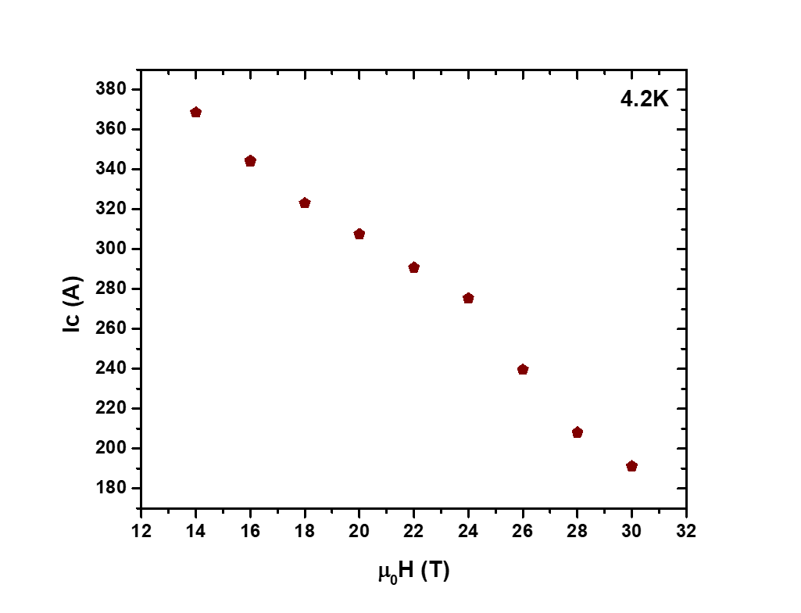

**Figure 1** (left) Current-voltage characteristic at 4.2 K, 20 T of a 1.62 mm diameter round REBCO wire bent to a diameter of 3 cm. (right) Magnetic field dependence of critical current of this wire at 4.2 K, 14 T – 30 T.

**Conclusions**

Our results show that ultra-small diameter round REBCO wires can sustain a good level of critical current in high magnetic fields at 4.2 K even when bent to a diameter of 3 cm. Further work is underway to target Je above 300 A/mm2 at 4.2 K, 20 T in round REBCO wires bent to 3 cm diameter.

**Acknowledgments**

A portion of this work was performed at the National High Magnetic Field Laboratory, which is supported by National Science Foundation Cooperative Agreement No. DMR-1157490 and the State of Florida. The work at the University of Houston was partially funded by award DE-SC0016220 from the U.S. Department of Energy Office of High Energy Physics. The work at AMPeers was funded by award DE-SC0015983 from the U.S. Department of Energy Office of High Energy Physics.

**References**

[1] Luo, W., *et al*., IEEE Trans. Appl. Supercond., **27**, 6602705 (2017)

[2] Kar, S., *et al*., IEEE Trans. Appl. Supercond., **27**, 6603204 (2017)