Nematic superconductivity under pressure in CeRhIn₅

Helm, T. and Moll, P.J.W. (Max Planck Institute CPFS); Grockoviak, A.D. and Tozer, S. (NHMFL Tallahassee) Balakirev, F. (NHMFL Los Alamos) Ronning, F. and Bauer, E.D. (Los Alamos National Laboratory)

Introduction
Recently, a nematic phase emerging at magnetic fields above 30 T was observed in the heavy-Fermion superconductor CeRhIn₅ [1]. The in-plane conductivity develops a sudden anisotropy at low temperatures, which is linked to the magnetic field orientation. This reduction in symmetry of the electronic system appears to be decoupled from the atomic lattice: magnetic and structural probes, such as torque magnetometry and magnetostriction detect almost no changes in the relevant field range. Nematic order has been observed in many other superconducting compounds and was suggested to be a possible candidate to support high-temperature superconductivity [2]. At zero field, CeRhIn₅ exhibits unconventional superconductivity (SC) for isotropic pressures above 10 kbar [3,4]. This motivated us to map out the full pressure-field-temperature phase diagram, and to investigate a possible connection between the high-field and the high-pressure phenomena.

Experimental
Electrical-transport measurements at high-pressure were performed in a 65 T pulsed magnet system (Multi shot 25 ms) in a 3-He cryostat at temperatures of 0.6 K - 50 K. Especially designed microstructures of single-crystalline CeRhIn₅ - structured by the application of focused ion beams (FIB) - in combination with plastic diamond anvil pressure cells enabled multi-terminal-transport experiments under pressures of up to ~21 kbar.
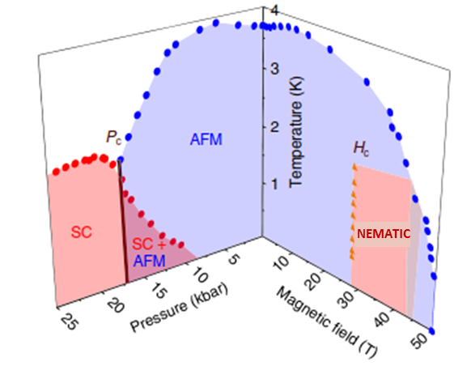
Results and Discussion
The main goal of this initial run was to demonstrate the viability of pulsed field measurements of FIB-prepared crystal microstructures within a pressurized diamond anvil cell. This approach proved successful, and pulsed field data was collected at few pressure points of up to 20 kbar in two different microstructured samples (see Fig. 2). The high-field nematic phase, indicated by a sudden anisotropy above 30 T, is well reproduced in a multi-terminal sample on an assembled diamond anvil pressure cell at almost negligible pressure, estimate below ~1 kbar. The pressure was determined via in-situ detection of the ruby fluorescence lines. The upcoming experiments will enable us to complete the phase diagram.
Fig. 1 Pressure-field phase diagram of CeRhIn₅ for field applied along the c-direction [3,4].

Conclusions
Even this first developmental experiment showed extremely promising results: For the first time diamond anvil pressure cells and FIB microstructured single crystals were successfully combined for electrical transport experiments in high fields, high pressures and at low-temperatures.

Acknowledgements
A portion of this work was performed at the National High Magnetic Field Laboratory, which is supported by National Science Foundation Cooperative Agreement No. DMR-1157490 and the State of Florida. The work of TH and PJWM is supported by the Deutsche Forschungsgemeinschaft (DFG) Grant MO 3077/1-1.
Fig. 2 Magnetorsistance recorded at various temperatures for two current configurations, I || [100] and [010], with field applied out of plane. Nematic anisotropic phase is visible above 30 T. The kink at around 50 T marks the suppression of antiferromagnetism (AFM).

References
[1] Ronning, F. et. al., Nature 548, 313–317 (2017)
[2] Lederer, S., PRL 114, 097001 (2015)
[3] Park, T. & Thompson, J. D., NJP 11, 055062 (2009)
[4] Jiao, L. et al. Proc. Nat. Acad. Sci. USA 112, 673–678 (2015)

