Fermi Surface of Nd-LSCO via Angle-Dependent Magnetoresistance

Legros, A., Laliberté, F., Doiron-Leyraud, N. and Taillefer, L. (Université de Sherbrooke, Canada); Goddard, P. (University of Warwick, IK); Ramshaw, B.J. (Cornell University, USA)

Introduction
Identifying the origin and nature of the pseudogap state in hole-doped cuprates is a key issue of high-Tc superconductivity. As the doping increases across the pseudogap critical point p*, the Fermi surface of cuprates goes from a small hole-like Fermi surface in the pseudogap state (p < p*), containing a carrier density n = p, to a large hole-like Fermi surface containing a carrier density n = 1+p for p > p* [1]. Understanding the mechanism of this Fermi surface transformation across p* could lead to the identification of the pseudogap state. Previous angle-dependent magnetoresistance (ADMR) measurements on two hole-doped cuprates enabled us to map out the 3D Fermi surface in two specific regions of the phase diagram: well above p*, in Tl2201 [2], and in the region of charge order well below p*, in YBCO [3]. What we were seeking in this project is to carry out the same kind of study in one material as we go across p*. We performed preliminary measurements on the cuprate Nd-LSCO, where p* = 0.23 [4], at dopings from p = 0.20 to p = 0.25.

Experimental
We performed ADMR measurements on four Nd-LSCO samples (with dopings p=0.20, p=0.22, p=0.23 and p=0.25) at low temperature (between 1.6 K and 25 K) and in magnetic fields up to 45 T. We measured the c-axis resistivity, sitting at a fixed field and rotating the angle θ between the c axis and the magnetic field. We repeated this for different azimuthal angles Φ.

Results and Discussion
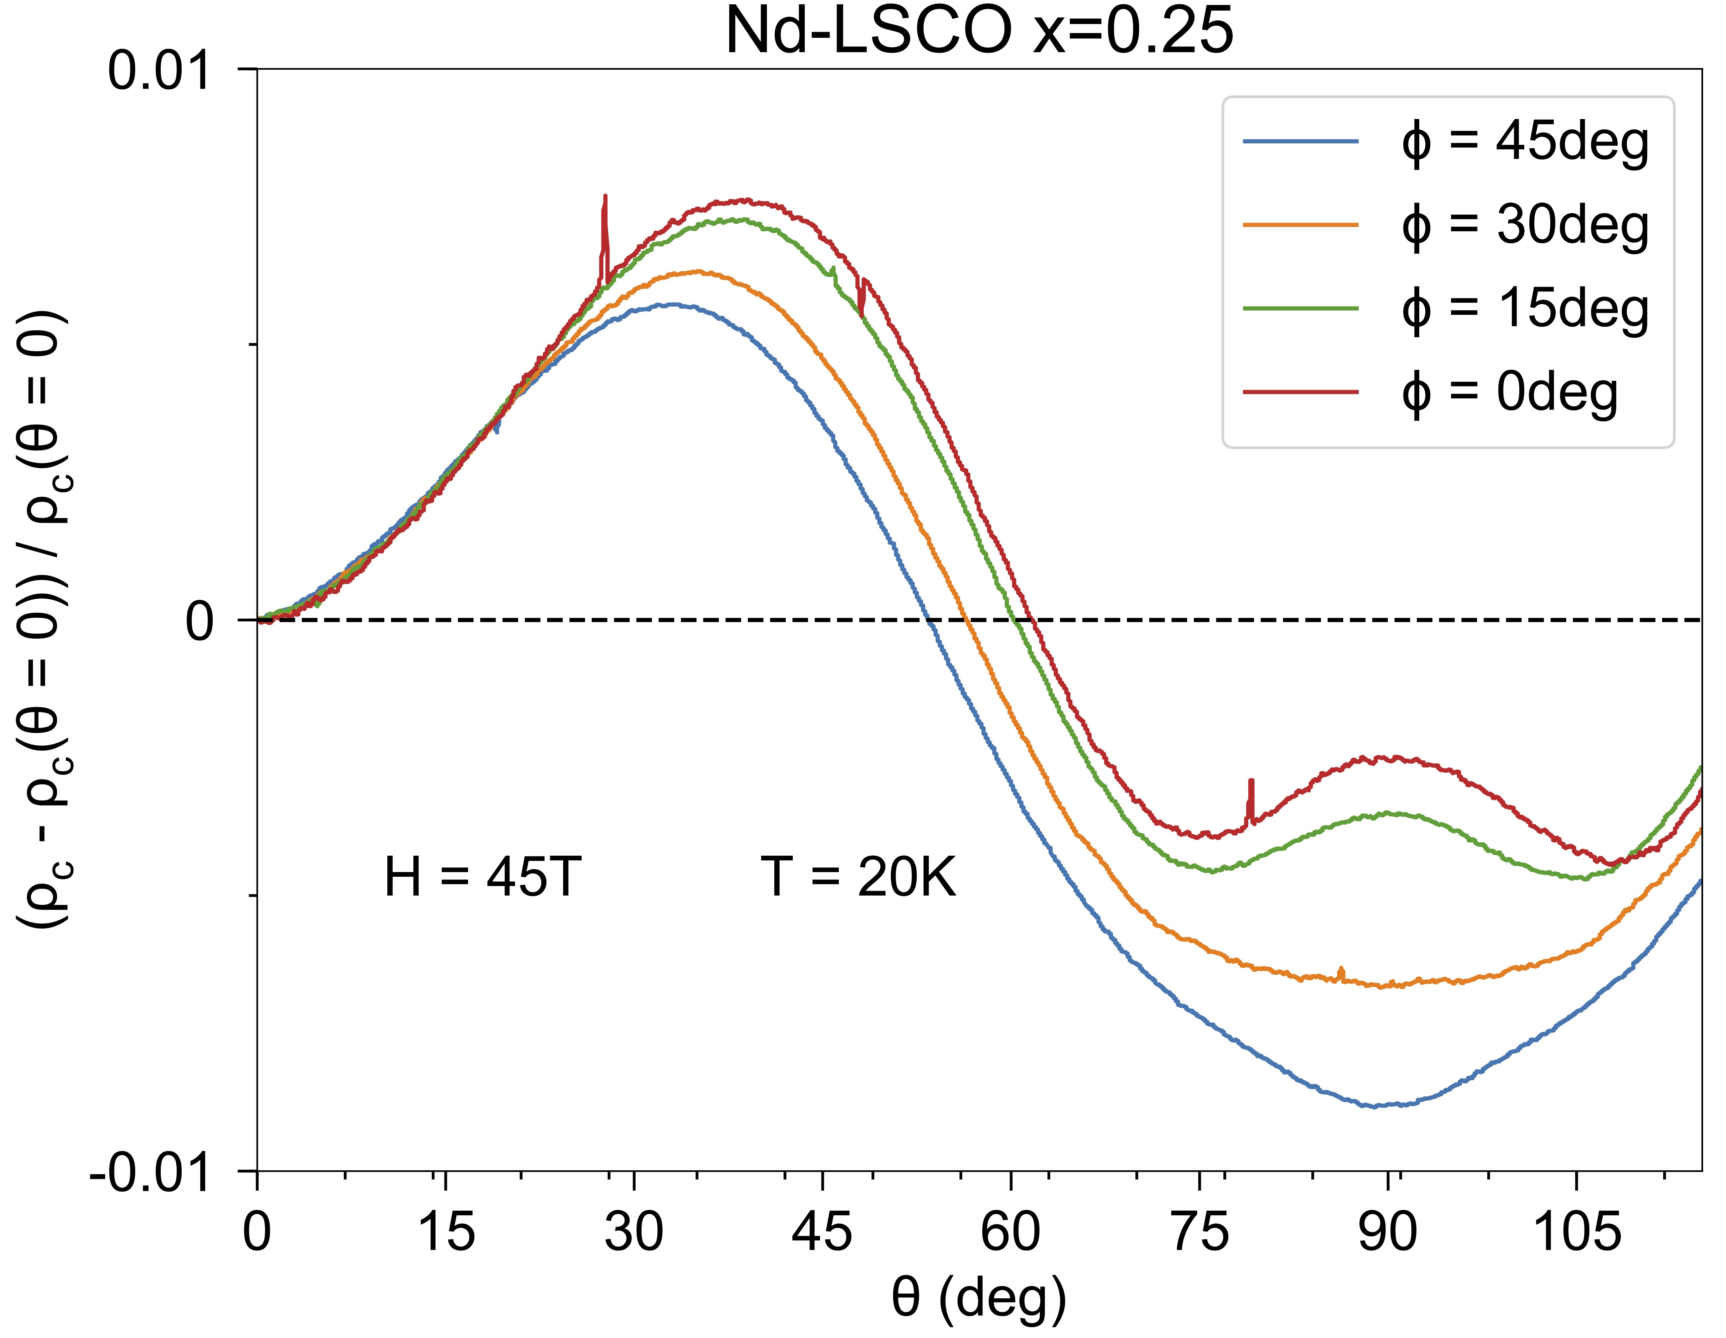
We observed a distinct θ and Φ dependence of the magnetoresistance in our samples, which are strongly enhanced when going to high field and low T. We are still in the process of analyzing the data. The general shape of the θ and Φ dependences at p = 0.25 (Fig.1) are consistent with the Fermi surface of Nd-LSCO measured by ARPES at p = 0.24 [5].

Conclusions
We obtained clean ADMR data for Nd-LSCO single crystals with dopings below and above p*. The 45T field enabled us to suppress the superconductivity down to low T at almost every θ. Simulations of our ADMR curves will give us information on the topology of the Fermi surface as the system crosses p*.

Acknowledgements
A portion of this work was performed at the National High Magnetic Field Laboratory, which is supported by National Science Foundation Cooperative Agreement No. DMR-1157490 and the State of Florida.

References
Fig.1 ADMR curves for Nd-LSCO at p = 0.25, T = 20 K and H = 45 T, for various values of the azimuthal angle.
[1] Badoux, S., et al., Nature, 531, 210–214 (2016).
[2] Hussey, N. E., et al., Nature, 425, 814-817 (2003).
[3] Ramshaw, B. J., et al., npj Quantum Materials, 2, 8 (2017).
[4] Collignon, C., et al., Physical Review B, 95, 224517 (2017).
[5] Matt, C. E., et al., Physical Review B, 92, 134524 (2015).

