Andreev Processes at an Interface between Graphene and a Superconductor
Benyamini, A.; Telford, E.; Wang, D.; Pasupathy, A.N. (Columbia University, Physics)

Introduction
Graphene, a two-dimensional (2d) zero-gap relativistic semiconductor exhibiting integer and fractional quantum hall, and superconductors (SC) are two different systems exhibiting competing many-body phenomena. An overlap between the two could yield novel phenomena, as non-abelian statistics, Majorana and para-fermions. A fundamental question is what happens to charge conversion at the interface, known as Andreev processes (AP), specifically the diverse physics of graphene should enable exploration of AP in new physical regimes.
Experimental
A significant technical challenge is fabricating graphene-SC interfaces that are highly transparent and robust under high magnetic fields. In our NHMFL sessions we managed to solve both challenges. Our initial efforts with FeTeSe, as the high critical magnetic field SC, failed and we progressed to sputtered NbN which solved both problems. Our devices are fabricated using the dry polymer transfer technique to integrate 2D materials as graphene, graphite and boron-nitride into stacks which we etch to edge-contact graphene with NbN. Measurements were performed at variable temperatures and high fields (in and out of plane) in SCM1, SCM2, and Cell 12.
Results and Discussion
In our first generation of back-gated graphene-NbN devices with low-junction resistance we explored AP in parallel field and saw first evidence that we can explore specular and retro-reflection APs with a new level of tunability. Figure 1a shows the graphene-NbN normalized differential conductance as a function of DC bias and gate voltage at 300mK. The areas of increased conductance correspond to retro and specular APs. Figure 1b shows a measurement at $B_{∥}=18T$. The dashed line which we interpret as the boundaries between retro and specular APs clearly changed, creating an increased specular region. The increase can be qualitatively understood by a Zeeman splitting of the graphene spectrum, though quantitively the increase is larger than expected.
In addition to measuring graphene/SC interfaces, we achieved the following thanks to facilities at the NHMFL:
- Demonstrated the robustness of a novel contact method for 2D air-sensitive materials^{[1]}
- Investigated the nature of the anomalous metallic state in a 2D superconductor (NbSe2)
- Investigated non-equilibrium behavior in a 2D superconductor (NbSe2) (manuscript in preparation)
Conclusions
The observation of clear zero-field Andreev processes and robust SC up to 18T demonstrates we can achieve high transparency junctions and is promising for the prospect of studying novel emergent phenomena.
Acknowledgements
A portion of this work was performed at the National High Magnetic Field Laboratory, which is supported by National Science Foundation Cooperative Agreement No. DMR-1157490 and the State of Florida. Research supported by NSF MRSEC-Columbia in the Center for PASSS (DMR-1420634), and Honda Research Institute USA Inc.
References
[1] Telford, E., Benyamini, A., et al., submitted (Nano Letters 2017)
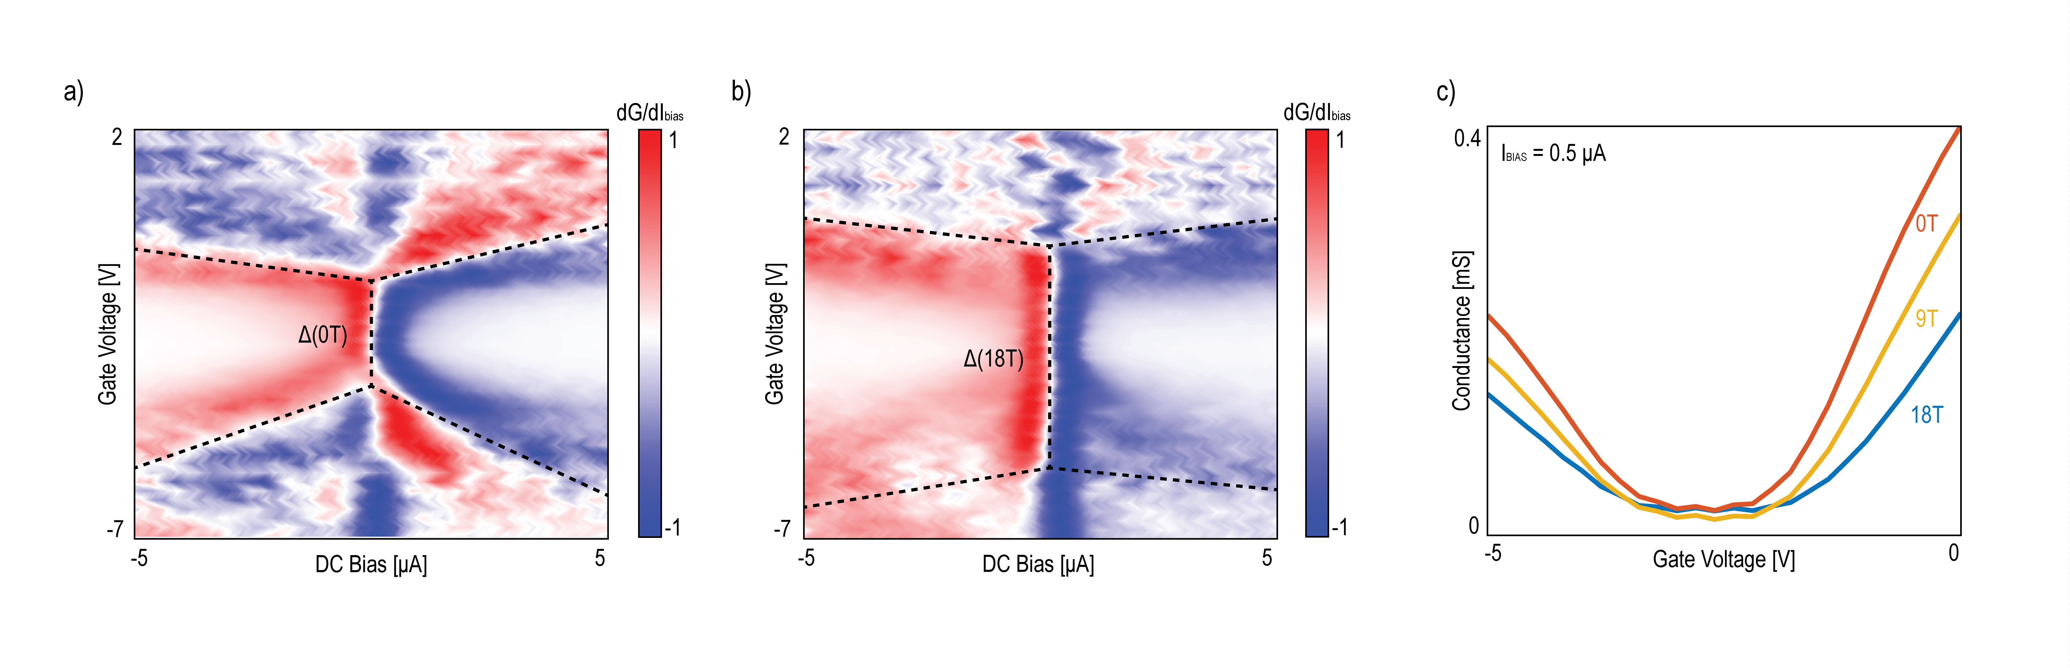
Figure 1 a,b) Derivative of differential conductance measured at 300mK at 0 and 18T in the parallel direction as a function of gate bias and DC current bias. We observe the distinct “cross” feature due to suppressed Andreev processes near the graphene

Figure 1 a,b) Derivative of differential conductance measured at 300mK at 0 and 18T in the parallel direction as a function of gate bias and DC current bias. We observe the distinct “cross” feature due to suppressed Andreev processes near the graphene

Figure 1 a,b) Derivative of differential conductance measured at 300mK at 0 and 18T in the parallel direction as a function of gate bias and DC current bias. We observe the distinct “cross” feature due to suppressed Andreev processes near the graphene

Figure 1. a,b) Derivative of differential conductance measured at 300mK at 0 and 18T in the parallel direction as a function of gate bias and DC current bias. We observe the distinct “cross” feature due to suppressed Andreev processes near the graphene charge neutrality point.

Figure 1 a,b) Derivative of differential conductance measured at 300mK at 0 and 18T in the parallel direction as a function of gate bias and DC current bias. We observe the distinct “cross” feature due to suppressed Andreev processes near the graphene

