Transport measurements in a high-T_{c} cuprate

Davies, A.J., Hartstein, M., Hsu, Y-.T., Juhász, P., Sanchez-Ricol, A., Sebastian, S.E. (Department of Physics, U. of Cambridge); Maier, S.A., Hannahs, S.T. (NHMFL, Tallahassee); Chan, M., Harrison, N., (NHMFL, Los Alamos).

Introduction
The nature of the pseudogap in the high-T_{c} cuprate superconductors is still being debated after almost three decades since there discovery. It has been proposed that the opening of a gap in the normal electronic ground state at temperatures above T_{c} could relate to either a precursor phase to superconductivity or an ordered phase that competes with superconductivity [1, 2]. We performed magnetoresistance measurements over a temperature range of several decades. Using high magnetic fields up to 35 T we were able to suppress superconductivity to investigate the onset of the pseudogap in greater detail.

Experimental
High-purity single-crystal YBa₂Cu₃O_{6+x} samples were grown by self-flux method and prepared for electrical transport measurements. The magnetoresistance for several different dopings was monitored over a range of temperatures using a top-loaded VTI cryostat and up to high fields in a 35 T DC field resistive magnet. Measurements were performed at the NHMFL in Tallahassee.

Results and Discussion
Single-crystal samples were wired in the conventional four-point method with negligible contact resistances that ensured a high signal-to-noise ratio. Using facilities at NHMFL, we successfully measured the Hall magnetoresistance in YBa₂Cu₃O_{6+x} as a function of temperature and field up to 35 T. Combining our measurements with low field PPMS data, we revealed how the curvature and sign change in the underdoped cuprates develops as superconductivity is suppressed at higher and higher fields.

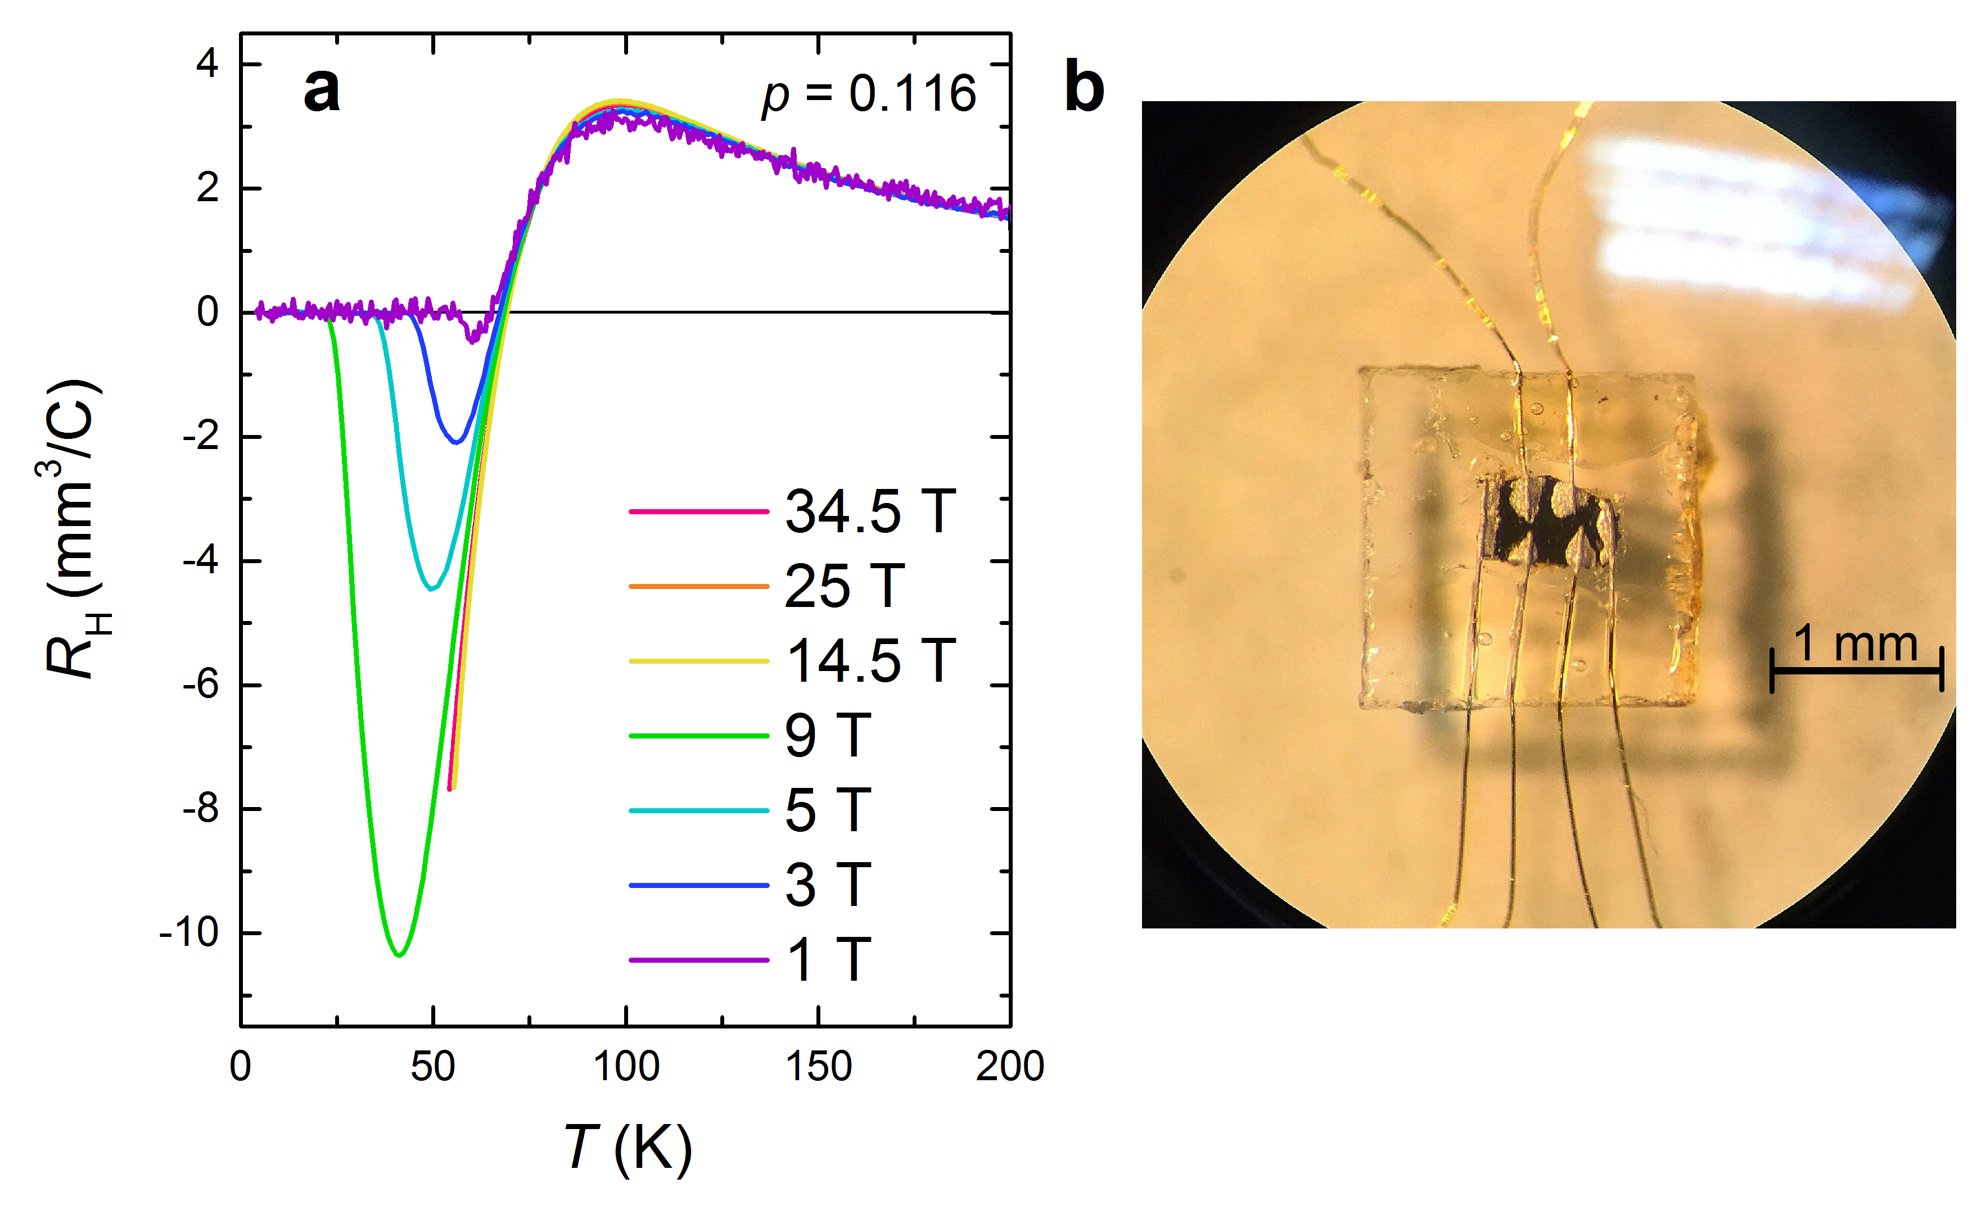

Fig.1a Magnetoresistance measurements of YBa₂Cu₃O_{6.55}. b Single-crystal high-T_{c} superconductor prepared for electrical transport measurements in high magnetic fields.

Acknowledgements
A portion of this work was performed at the National High Magnetic Field Laboratory, which is supported by National Science Foundation Cooperative Agreement No. DMR-1157490 and the State of Florida. We also acknowledge funding from EPSRC and ERC grants.

References
[1] Keimer, B., et al., Nature, 518, 179-186 (2015).
[2] Senthil, T., Lee, P., Phys. Rev. B, 79, 245116-245123 (2009).

