Field Induced Superconductor to Insulator Transition in SrTiO3/LaAlO3 (111)
Dagan, Y., Maniv, E., Rout, P.K., Mograbi, M. (TAU, Physics); Graf, D., Park, J.-.H. (NHMFL)

Introduction
In 2004 Ohtomo and Hwang showed that a conducting layer forms at the interface of the perovskite insulators Strontium Titanate (STO) and Lanthanum Aluminate (LAO)¹. The interface of these materials, grown in the (100) orientation, has been well studied and exhibited a wide range of gate controlled phenomena such as superconductivity², ferromagnetism³ and strong spin orbit interaction⁴.
Recently, it has been shown that conductivity arises in the (111) STO/LAO interface as well. While this interface is similar to the (100) interface in many ways, it also has some unique properties such as 6-fold symmetric anisotropic magnetoresistance⁵ and positive charge carriers⁶.
Experimental
Measurements were conducted in the milikelvin SCM1 at the NHFML. The sample was cooled to 20 mK and its resistance was measured as a function of perpendicular and parallel magnetic fields up to 18 Tesla. The measurements were repeated for gate voltages ranging from -30 Volt to -70 Volt.
Results and Discussion
The measurements show a nonmonotonic dependence of the resistance on magnetic field, as shown in Fig.1. This unusual behavior is indicative of a superconductor to insulator transition (SIT) induced by the magnetic field, a transition which has been described theoretically⁷ as well as shown experimentally in several other materials^{8,9}.
There is a clear difference in the effect of perpendicular and parallel field, both in the magnitude of the change in resistance as well as in the field at maximum resistance. This difference is due to the fact the conducting layer is two dimensional, meaning only perpendicular fields create vortices. Because the SIT involves condensation of voritces, the effect will be much stronger in perpendicular fields.
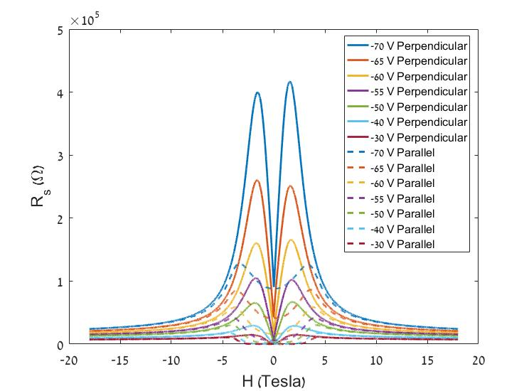
The decrease of gate voltage pushes the sample deeper into the insulating phase, showing that the gate voltage effectively tunes the disorder in the sample.
Conclusions
The results clearly show the SIT in STO/LAO
(111) and allow us to map phase diagram of the
interface as a function of magnetic field and disorder. Measurements recently conducted in Tel-Aviv University show the temperature dependence of the transition, giving the full 3D phase diagram as described in the theory.
Acknowledgements
A portion of this work was performed at the
National High Magnetic Field Laboratory, which is
supported by National Science Foundation
Cooperative Agreement No. DMR-1157490 and the State of Florida. Support from the Israeli Science Foundation is acknowledged
References
[1] Ohtomo A., et al., Nature, 427, 423(2004).
Fig.1 Resistance as a function of perpendicular and parallel magnetic fields for different gate voltages.
[2] Caviglia A. D., et al., Nature, 456, 624-627 (2008).
[3] Bert J. A., et al., Nature physics, 7, 767-771 (2011).
[4] Ben Shalom M., et al., Physical Review Letters, 104, 126802 (2010).
[5] Rout P. K., et al., Physical Review B, 95, 241107 (2017).
[6] Davis S., et al., Physical Review B, 95, 035127 (2017).
[7] Fisher M. P. A., Physical Review Letters, 65, 923 (1990).
[8] Baturina T. I., et al., Physical Review Letters, 98, 127003 (2007).
[9] Steiner M. A., et al., Physical Review B, 77, 212501 (2008).

