Pressure effects show that the pseudogap phase of cuprates is confined
by Fermi surface topology

Doiron-Leyraud, N., Cyr-Choinière, O., Badoux, S., Ataei, A., Collignon, C., Gourgout, A., Dufour-Beauséjour, S., Tafti, F.F., Laliberté, F., Boulanger, M.-E., Matusiak, M., Taillefer, L. (U. de Sherbrooke); Graf, D. (NHMFL); Kim, M. (Collège de France); Zhou, J.-S. (U. of Texas, Austin); Takagi, H. (U. of Tokyo)

Introduction
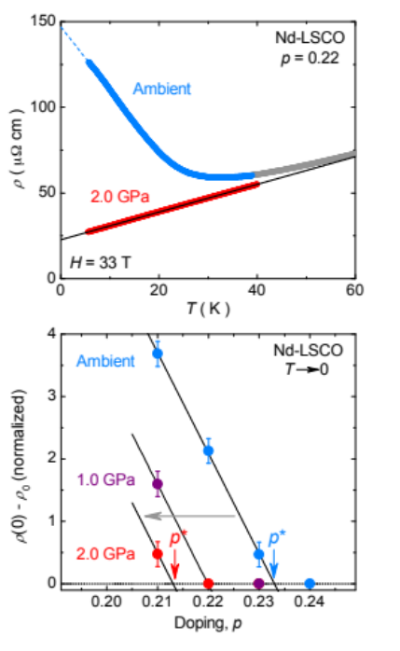
The properties of cuprate high-temperature superconductors are largely shaped by competing phases whose nature is often a mystery. Chiefly among them is the pseudogap phase, a defining universal property of cuprates that sets in at a doping p*. What determines p* is currently an open question, and why it is much lower in La_{2-x}Sr_{x}CuO₄ (p* = 0.18 [1]) than in La_{1.6-x}Nd_{0.4}Sr_{x}CuO₄ (Nd-LSCO, p* = 0.23 [2,3]), for example, is unknown.

Experimental
We examined this question via a series of low-temperature high-magnetic-field measurements of the electrical transport in Nd-LSCO under hydrostatic pressure, performed at the NHMFL in cells 12 and 15. Our study is based on transport signatures of the pseudogap which, for p < p*, take the form of large upturns at low temperature in the Hall coefficient [4] and the electrical resistivity [5], attributed to a drop in carrier density n from n = 1 + p above p* to n = p below p* [3,4]. In Fig. 1, this upturn is clearly visible in the ambient pressure data on Nd-LSCO at p = 0.22.

Results and Discussion
Hydrostatic pressure is not known to have an impact on the pseudogap phase, and yet our data reveal a large and unexpected suppression of the resistivity upturn in Nd-LSCO with pressure. At p = 0.22 under 2.0 GPa, the suppression is full and we observe a linear-T resistivity typical of the regime, at p* and above [1,2,3]. Given that the doping remains constant with pressure, we interpret our data as a pressure-induced suppression of p*. Taking the amplitude of the upturn as a measure of the distance from p*, we observe a shift from p* = 0.23 down to p* ~ 0.21 under 2.0 GPa. Our Hall effect data above p* on Nd-LSCO [6] show that pressure induces the very same shift on the position of p_{FS}, the doping at which the van Hove singularity crosses the Fermi level and makes the large Fermi surface go from hole-like to electron-like. As we explain in our article [6], it is this shift in p_{FS} that drives the shift in p*, such that the condition p* ≤ p_{FS} must hold, showing that the pseudogap can only open on a hole-like Fermi surface.
Fig. 1: Top: electrical resistivity vs temperature for Nd-LSCO at p = 0.22, under ambient pressure and 2.0 GPa. Bottom: amplitude of resistivity upturn vs doping, at pressures as indicated.

Conclusions
This necessary condition for pseudogap formation, imposed by details of the Fermi surface, is a strong constraint for theories of the pseudogap phase. In addition, our finding that p* can be tuned with a modest pressure opens a new route for experimental studies of the pseudogap.

Acknowledgements
A portion of this work was performed at the NHMFL, which is supported by National Science Foundation Cooperative Agreement No. DMR-1157490 and the State of Florida. We acknowledge support from CIFAR, NSERC, FRQNT, CFI, the Gordon and Betty Moore Foundation, and a Canada Research Chair.

References
[1] R. A. Cooper et al., Science 323, 603 (2009).
[2] R. Daou, et al., Nat. Phys. 5, 31 (2009).
[3] C. Collignon et al., Phys. Rev. B 95, 224517 (2017).
[4] S. Badoux et al., Nature 531, 210 (2016).
[5] F. Laliberté et al., arXiv:1606.04491 (2016).
[6] N. Doiron-Leyraud et al., Nature Communications 8, 2044 (2017) (DOI:10.1038/s41467-017-02122-x).

