Universality of STM Images in Cuprate Superconductors
Hirschfeld, P.J., Choubey, P. (UF Physics); Kreisel, A., Andersen, B.M. (N.Bohr Inst.); Berlijn, T. (ORNL)

Introduction
Theoretical calculations of STM images on cuprate superconductors have been confined almost exclusively to models of electrons hopping on a lattice corresponding to the Cu sites in the CuO₂ plane. We have recently shown that a Wannier function-based method allowing continuum calculations can resolve several puzzles regarding impurity states, quasiparticle interference patterns, and charge correlations in BSCCO-2212 [1,2]. One remaing question has been that different cuprates, e.g. BSCCO-2212 and Na-CCOC have very different tunneling barrier layers near the the surface, yet charge and impurity patterns observed are nearly identical[3].

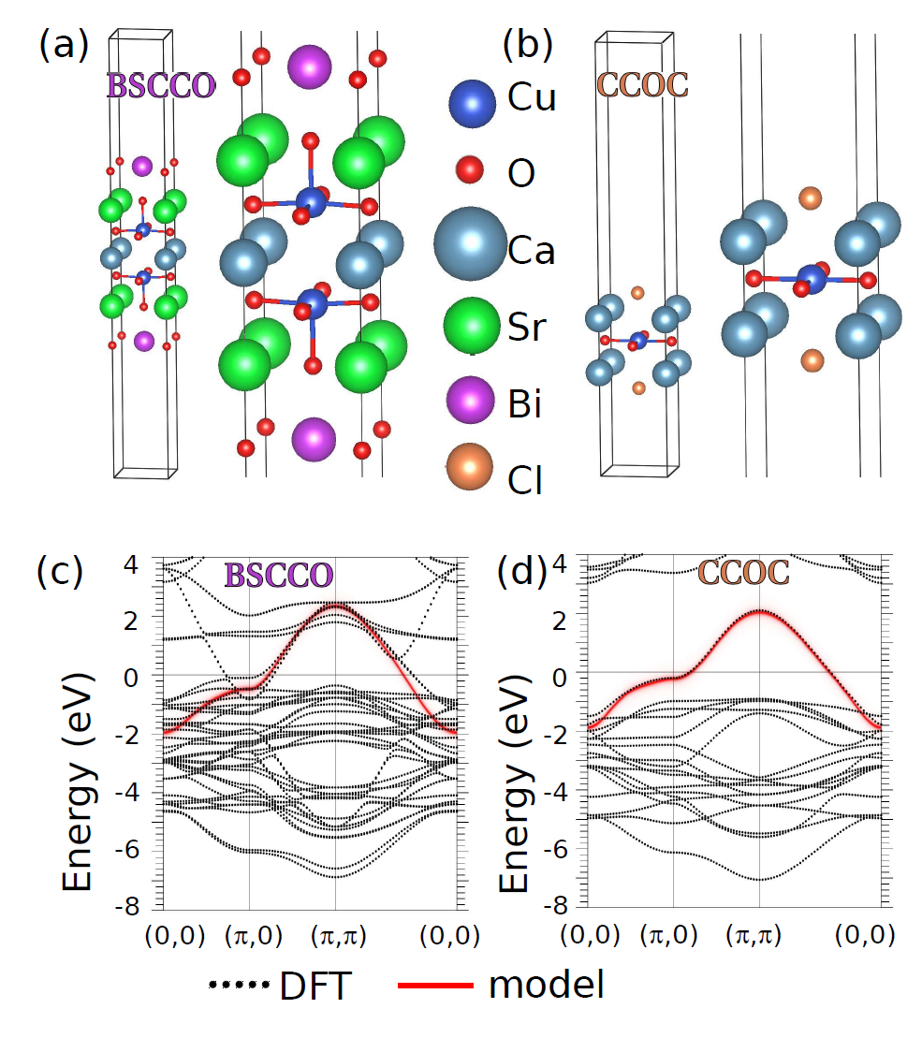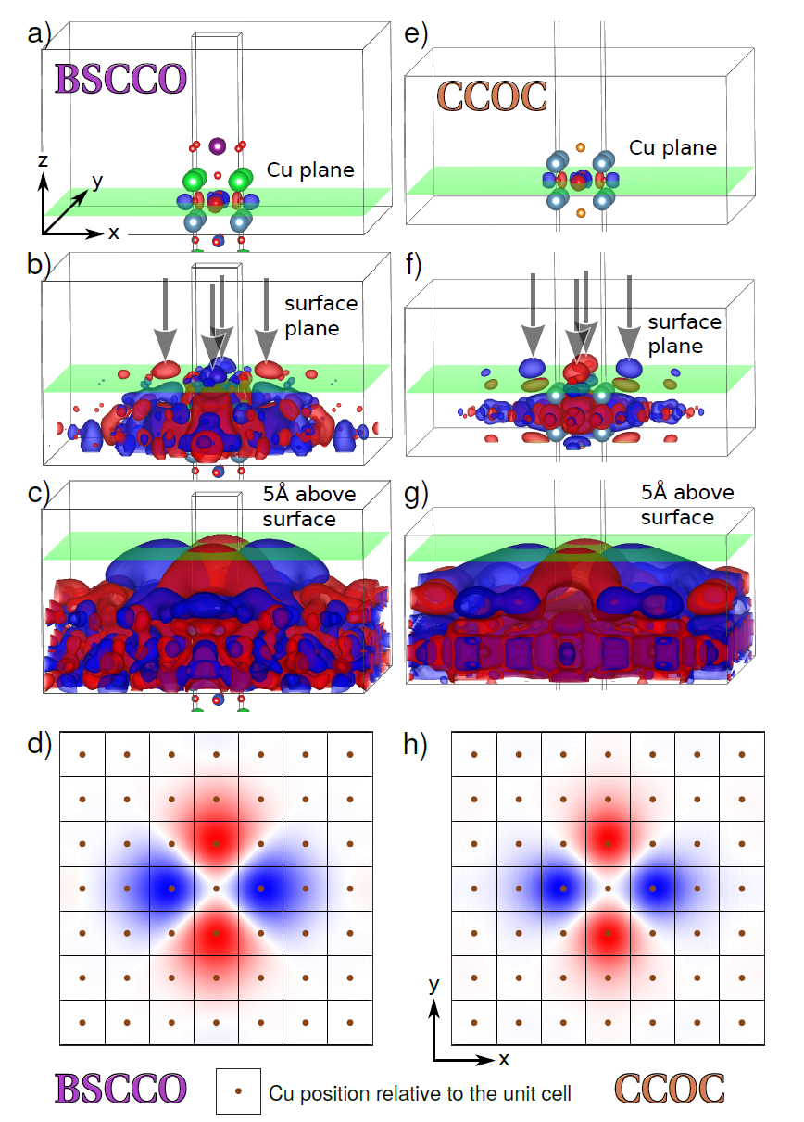
Left: crystal and band structures (DFT) for BSCCO-2212 and CCOC. Right: Cu d_{x2-y2} Wannier function for the two systems from VASP and Wannier90 software packages. Shown are different isovalues of the wave function, with green planes indicating the Cu crystal plane, surface plane and plane above surface at STM tip location. Bottom two panels show cut through Wannier function at STM tip height.

Results and Conclusions
As seen in the figure, despite quite large differences in the crystal structures near the cleaved surfaces in the two systems, as well as important differences in the near-field structure of the d_{x2-y2} Wannier function, 5Å above the surface the two functions are essentially identical. We calculated patterns for impurity states to confirm the extremely similar physical observables; the “filters” controlling the STM images of the CuO₂ planes are the same.

Acknowledgements
Supported by NSF-DMR-1407502.

References
[1] Kreisel, P. Choubey, T. Berlijn, B. M. Andersen and P. J. Hirschfeld, Phys. Rev. Lett. 114, 217002 (2015)
[2] P. Choubey, W.-L. Tu, T.-K. Lee, and P. J. Hirschfeld, New J. Phys. 19, 013028 (2017).
[3] Y. Kohsaka et al. Science 315, 1380 (2007).
[4] P. Choubey, A. Kreisel, T. Berlijn, B. M. Andersen, and P. J. Hirschfeld, Phys. Rev. B 96, 174523 (2017).

