Transport Properties of Magnetic-Field Induced Topological Phases in Pyrochlore Iridate Thin-Films

Gruenewald, J.H. and Seo, A. (U. of Kentucky, Physics and Astronomy); Kim, W.J. and Noh, T.W. (Seoul Nat’l. U., Physics and Astronomy); Choi, E.S. (NHMFL)

Introduction
Non-trivial topological insulators are known to possess topologically-protected, robust surface states. Pyrochlore lattices of strongly correlated and spin-orbit coupled electrons exhibit intriguing topological properties such as Weyl semimetals depending on their spin configurations and broken time reversal symmetry. More interestingly, their topological properties are contingent on the effective correlation energy U_{eff} of the system. Here we report our recent studies on the magnetic field-induced topological phases in pyrochlore iridate thin-films and their robust magneto-transport properties.

Experimental
We have synthesized a series of mixed phase pyrochlore iridate thin-films ((A,B)₂Ir₂O₇ for (A,B) = (Pr_{1/2}Nd_{1/2}); (Pr_{1/3}Nd_{2/3}); (Nd); (Sm_{1/3}Nd_{2/3}); (Sm_{1/2}Nd_{1/2}); (Sm_{2/3}Nd_{1/3}); (Sm)) on diamagnetic wide-bandgap-insulating Y:ZrO₂ substrates using a combination of pulsed laser deposition and a high-temperature anneal in ambient. While the structural properties of the mixed phase thin-films are comparable to that of bulk crystals, their transport properties infer that these samples contain significant amount of disorder or defects (data not shown). Nevertheless, it is of interest to check whether they show robust surface states due to topologically protected nature. We investigated these samples’ transport properties as a function of temperatures and magnetic fields using the superconducting magnet system (SCM2) at NHMFL.

Results and Discussion
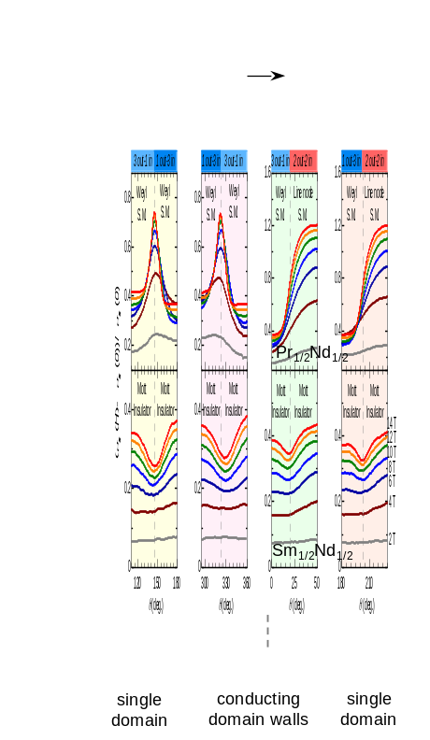
Magnetic field sweeps directed parallel to the [111] and [001] axes induces distinct topological phases, i.e. domains, and conducting surface-states, i.e. domain walls, for the mixed phase Pr_{1/2}Nd_{1/2} while the Sm_{1/2}Nd_{1/2} thin films retain directional independence (data not shown). Note that these two pyrochlore iridates are located across the phase boundary between a Weyl semimetal and Mott insulator, respectively [1].
Fig.1 Angular dependence of magneto conductance of PrNdIr₂O₇ and SmNdIr₂O₇ thin-films. (Red curve is under the highest magnetic field.)
To investigate the surface states of the magnetic field-induced topological phases, we have measured the transport properties of these thin-films by rotating the direction of magnetic fields. When the applied field induces a transition between time-reversal pair spin-configurations, e.g. ‘3 out – 1 in’ to ‘1 out – 3 in’ (Fig. 1), there is a propagation of domain walls (bottom schematic in Fig. 1). The spike in conductivity observed for Pr_{1/2}Nd_{1/2} indicates that the domain walls are more conductive than domains while Sm_{1/2}Nd_{1/2} exhibits the opposite behavior.
Our experimental observations the pyrochlore iridate thin films strongly suggest the robust nature of the topologically protected conducting surface-states in Weyl semimetals (e.g. PrNdIr₂O₇) and insulating surface-states in Mott insulators (e.g. SmNdIr₂O₇) depending on U_{eff}. It is noteworthy that these surface states survive even under significant disorder in thin-film samples.

Acknowledgements
We acknowledge the support of National Science Foundation grant DMR-1454200 for sample synthesis. A portion of this work was performed at the National High Magnetic Field Laboratory, which is supported by National Science Foundation Cooperative Agreement No. DMR-1157490 and the State of Florida.

References
[1] Ueda, K. et al., Nature Comm. 8, 15515 (2017).

