Fermi surface of the type-II Dirac semimetallic candidate PdTe₂

Zheng, W., Chiu, Y.C., Schoenemann, R. and Balicas, L. (National High Magnetic Field Laboratory)

Introduction
PdTe₂ was predicted to be a Dirac type-II semimetal with Dirac points located at about 0.5 eV below the Fermi level. It crystallizes in a centrosymmetric trigonal crystal structure with space-group P3m1. A single pair of type-II Dirac points, which are protected by the trigonal rotation symmetry, exists on the k_{z} axis of the bulk BZ [1].

Experimental
AC transport experiments on PdTe₂ on single crystals have been conducted in a ³He cryostat in cell 12 up to 34.5 T using a rotator probe. A conventional four terminal method was used to measure the sample resistance. Cantilever torque measurement where performed via a capacitive method in SCM1 up to 18T using a rotator probe.

Results and Discussion
A full angular dependence of Shubnikov-de Haas (SdH) oscillations and de Hass-van Alphen (dHvA) oscillations have been measured which are not in perfect agreement with band structure calculations. We obtained effective masses for fields along the c-axis and ab-plane in the order of 0.01 free electron masses.
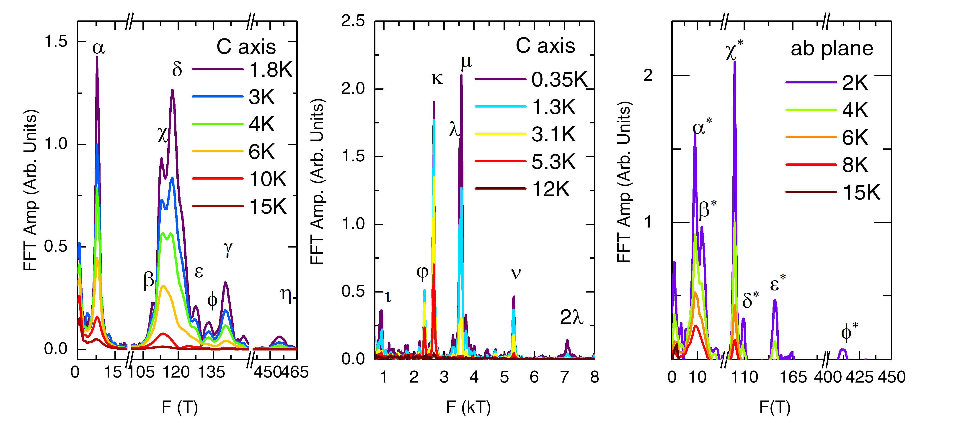Conclusions
Fig.1 The FFT spectra of the oscillatory signal superimposed on the torque or magnetoresistivity for fields along a planar or of inter-planar direction and for various temperatures.
PdTe₂ displays a very low residual resistivity, i.e. p ≈ 400 nΩ∙cm at 2K. At the moment the reason for the discrepancy between the experimental and calculated Fermi surface remains unclear. The large number of FFT frequencies observed in two directions (Figure 1) precludes a reliable extraction of the Berry phase for each frequency, but dHvA measurements performed under low fields revealed a nontrivial Berry phase for the frequency F ~ 8T in PdTe₂ crystals at low temperatures as extracted from the Landau fan diagram. The effect of the underlying Dirac points on its transport properties remains to be clarified.

Acknowledgements
This work was supported by DOE-BES through Award N. DE-SC0002613. A portion of this work was performed at the National High Magnetic Field Laboratory, which is supported by National Science Foundation Cooperative Agreement No. DMR-1157490 and the State of Florida.

References
[1] Huang, HQ., et al., Phys. Rev. B, 94 , 121117(R) (2016).

