Critical current measurements in the high field phase of TaAs
Bachmann, M.D. (MPI-CPFS, Germany); Ramshaw, B.J.; Zhang Y.; Kim, E.-A. (Cornell University); Modic, K.A.; Moll, P.J.W. (MPI-CPFS, Germany); Shekhter, A. (NHMFL); Chan, M.K.; Betts, J.B.; Balakirev, F.; Migliori, A.; Ghimire, N.J.; Bauer, E.D.; Ronning, F. and McDonald, R.D. (LANL)

Introduction
It was recently shown [1] that the Weyl semi-metal TaAs undergoes a drastic transformation in its electronic structure as a function of magnetic field (see Fig. 2). At 50T, well above the quantum limit, a breakdown of the zero-field bandstructure is observed, resulting in a two-order-of-magnitude increase in the resistivity for J||B||c. Because far in the quantum limit the electronic structure of a metal becomes essentially one- dimensional, the formation of density-wave states is favoured due to the perfect Fermi surface nesting in 1D.
Nonlinear I/V curves can reveal the presence of a density wave: above a threshold electric field the density wave de-pins and acts as a secondary transport channel. Even if the high field state is not a density wave phase, nonlinear transport will shed light on whether the state is gapped or whether it still contains gapless charged quasiparticles.
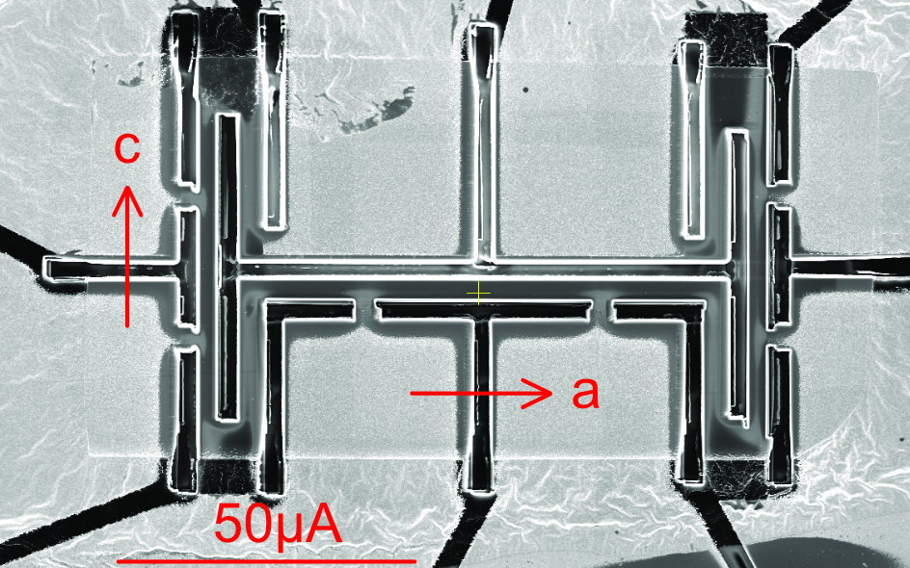
Experimental
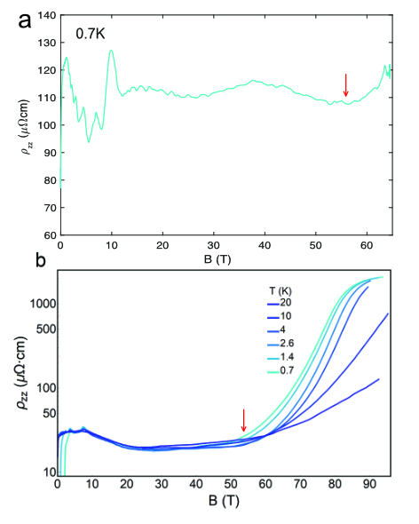
To achieve the large electric fields required for this experiment we have fabricated focused-ion-beam (FIB) prepared micro-structured samples: the high aspect ratio of these samples provides sufficiently large current densities that nonlinear I/V curves can be observed in otherwise good metals [2]. In preparation for the experiment in fields up to 100T, we have measured transport along both the a- and c-axes up to 65T at the Los Alamos National Laboratory.
Additionally we have investigated the difference between Xenon and Gallium ions for FIB milling with regards to the extrinsic superconducting Tantalum shell that forms upon irradiation [3].
Fig.1 TaAs sample prepared by plasma focused ion beam (Xe ions).

Results and Discussion
In Figure 2 we compare the results of the Xenon structured micro-device (top) from Fig. 1 to a Gallium cut crystal (bottom). The main transport features have stayed the same: The quantum limit is reached at around 10T. As the magnet field increases further the magnetoresistance stays constant until the upturn at 50T.
Moreover, despite displaying a lower superconducting transition temperature after using Xenon rather than Gallium ions, the formation of a Tantalum enriched surface could not be avoided.

Conclusions
We have successfully reproduced the main signatures of electrical transport in microstructured TaAs. The devices are now ready for the 100T magnet.

Acknowledgements
A portion of this work was performed at the National High Magnetic Field Laboratory, which is supported by National Science Foundation Cooperative Agreement No. DMR-1157490 and the State of Florida.

References
Fig.2 Comparison of the resistivity of the Xe-FIBed microstructured device (a) to a Ga-FIBed crystal. The current is applied along the c-axis, parallel to the magnetic field.
[1] Ramshaw, B.J., et al., manuscript submitted (2017)
[2] Moll, P. J. W., et al., Nature Communications 6:6663 (2015)
[3] Bachmann, M. D., et al., Science Advances 3 (2017)

