Landau Level Spectroscopy of Massive Dirac Fermions
in Single-Crystalline ZrTe₅ Thin Flakes

Jiang, Y., Jiang, Z. (Georgia Tech, Physics); Lu, Z., Chen, K.-W., Moon, S., Besara, T., Baumbach, R.E., Smirnov, D. (NHMFL); Dun, Z.L. and Zhou, H.D. (U. Tennessee, Physics)

Introduction
A quantum spin Hall (QSH) insulator is expected to have topologically protected states that enable dissipation-less transport and thus low-power device applications. Unfortunately, all the QSH insulators discovered to date possess a small band gap that is not suited for room temperature operations. Recently, ZrTe₅ has been predicted as a possible candidate for hosting a large-gap QSH insulator phase in their monolayer form and a three-dimensional topological insulator (TI) phase in the bulk [1]. However, the topological nature of bulk ZrTe₅ is currently under intense debate (based on recent experimental studies), with interpretations ranging from strong/weak TIs to Dirac semimetal. Our work aims at elucidating the mystifying electronic band structure of ZrTe₅ using the bulk-sensitive magneto-infrared (magneto-IR) spectroscopy techniques [2].

Experiment
Owing to its layered structure and the weak van der Waals force between layers, IR-transparent thin flakes of ZrTe₅ can be obtained by repeated exfoliation of the material using an IR-transparent Scotch tape. In addition to the conventional Fourier transform IR spectroscopy measurements, we have employed a newly developed circular polarization (CP) resolved technique by coupling a tunable Quantum Cascade Laser with a linear polarizer and a quarter wave-plate. To resolve the CP dependence and the corresponding optical selection rule, we fix the polarization and sweep between a positive and negative magnetic field. All measurements are performed at 4.2K and in Faraday configuration using the SCM3 superconducting magnet in the DC field facility.

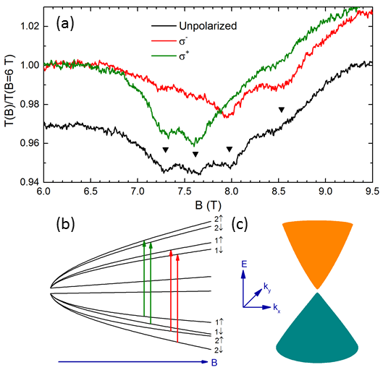
Results and Discussion
Fig.1: (a) Normalized transmission spectra measured with unpolarized and CP lights at fixed energy as a function of magnetic field. (b) Calculated LL fan diagram of ZrTe₅ and the corresponding inter-LL transitions observed. (c) Deduced electronic structure of ZrTe₅.
Figure 1(a) shows the four-fold splitting of an inter-Landau-level transition observed in the normalized magneto-transmission spectra of ZrTe₅. With CP IR light, we can resolve the transitions from different selection rules, as illustrated in Fig. 1(b). The degeneracy breaking between the two CPs is a direct evidence of electron-hole asymmetry, and the energies of CP active modes imply a steeper band velocity for electrons. The two-fold splitting within each CP can be attributed to a combined effect of finite mass and large g-factor. All observed modes follow a square root magnetic field dependence, which is a hallmark of Dirac fermions. Using an effective Dirac model, we can extract a mass of ~5meV and a g-factor as large as 24. The deduced electronic structure of ZrTe₅ is plotted in Fig. 1(c).

Conclusions
We have performed IR transmission measurements on exfoliated ZrTe₅ thin flakes and observed a four-fold splitting of low-lying LL transitions. CP resolved measurements show that a two-fold splitting comes from electron-hole asymmetry while the other two-fold is caused by lifting the spin degeneracy. Our result supports ZrTe₅ as a Dirac semimetal but with a small relativistic mass (or gap).

Acknowledgements
This work was primarily supported by the DOE (Grant No. DE-FG02-07ER46451). The ZrTe₅ crystal growth at UT was supported by the NSF (Grant No. DMR-1350002). A portion of this work was performed at the NHMFL, which is supported by NSF Cooperative Agreement No. DMR-1157490 and the State of Florida. Z.J. acknowledges support from the NHMFL Visiting Scientist Program.

References
[1] Weng, H. et al. Phys. Rev. X, 4, 011002 (2014).
[2] Jiang, Y. et al. Phys. Rev. B, 95, 045116(R) (2017).

