Fermi surface investigations of a pyrochlore iridate close to a quantum critical point

Gotze, K., Pearce, M., Goddard, P. (University of Warwick, UK); Boothroyd, A., Prabhakaran, D. (University of Oxford, UK); Singleton, J. (NHMFL-LANL).

Introduction
The family of Ln₂Ir₂O₇ pyrochlore iridates (Ln = Nd–Ho) exhibits a metal-to-insulator transition at a critical temperature T_{MI} accompanied by magnetic ordering, see Figure 1. Due to their lattice structure, which is composed of connected tetrahedra, the Ln₂Ir₂O₇ compounds can host different configurations of magnetic frustration that may lead to novel electronic states such as a topological band structure or Weyl semimetal behavior [1].

Experimental
Single crystals of the Ln = Nd member of the family were prepared. They grow in the form of truncated octahedra approximately 100 µm on each edge. Preliminary compensated-coil magnetometry and electronic transport measurements were performed on these samples at ³He temperatures in the 65 T short-pulse magnets at NHMFL-LANL. Several datasets were collected and, following a polynomial background subtraction, an oscillatory signal periodic in inverse magnetic field was isolated from the magnetic susceptibility data.

Results and Discussion
The oscillatory part of the susceptibility data observed in multiple field pulses at 600 mK is consistent with de Haas-van Alphen oscillations showing two distinct frequencies of approximately 200 T and 800 T, with the lower frequency dominating the low-field region. This was deduced from a Fourier analysis of the data, as well as by determining the positions of the maxima in the susceptibility and by comparing the oscillatory part of the data with simulations, see Figure 2. Follow-up measurements are required to confirm these preliminary results, to map out the temperature and angle-dependence of the oscillations, and compare with other members of the family.

Conclusions
Preliminary results suggest that we have observed de Haas-van Alphen oscillations in Nd₂Ir₂O₇ following suppression of the low-temperature insulating state using high magnetic fields. Further work is required to confirm the observation and elucidate the Fermi-surface characteristics.

Acknowledgements
A portion of this work was performed at the National High Magnetic Field Laboratory, which is supported by National Science Foundation Cooperative Agreement No. DMR-1157490 and the State of Florida. This project has received funding from the European Research Council (ERC) under the European Union’s Horizon 2020 research and innovation programme (grant agreement No. 681260).

References
[1] W Witczak-Krempa et al., Annu. Rev. Con. Mat. Phys. 5, 57 (2014)
[2] K Matsuhira et al., J. Phys. Soc. Jpn. 80, 094701 (2011).
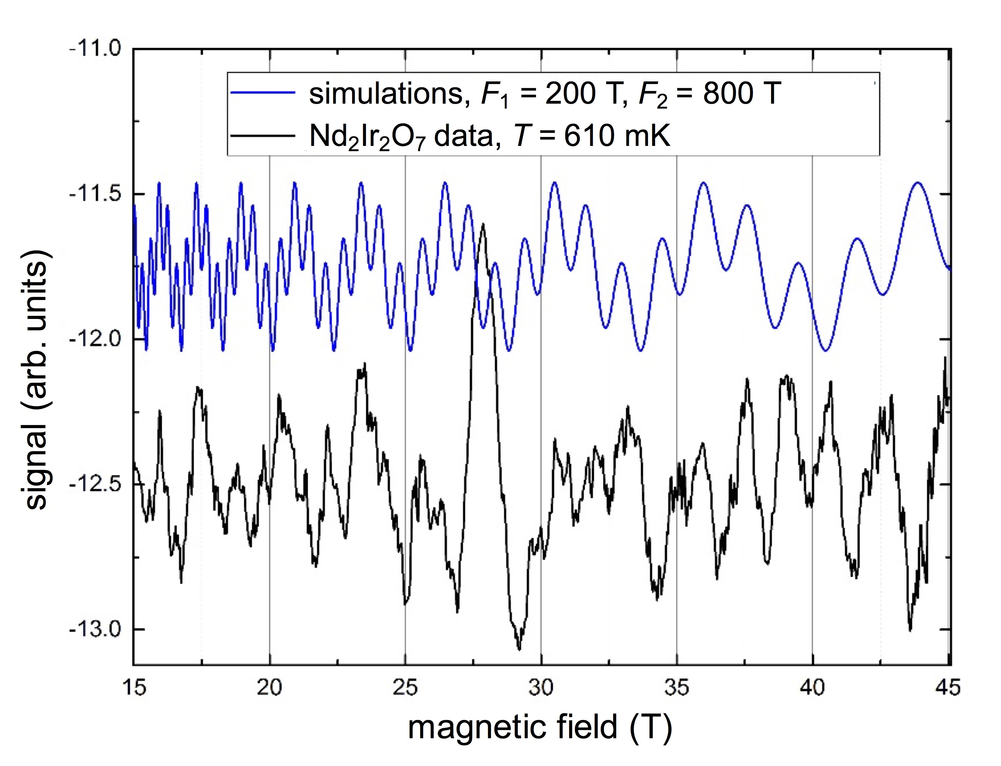
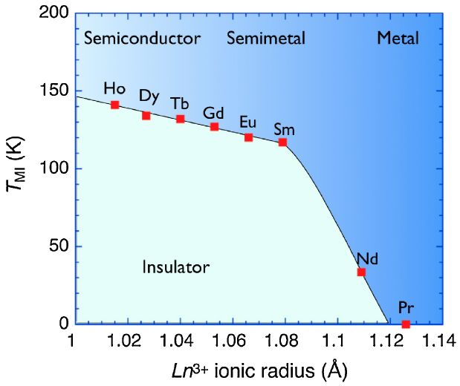
Fig.1 Phase diagram of Ln₂Ir₂O₇. T_{MI} is suppressed with increasing ionic radius of Ln. Figure taken from [2].
Fig. 2 Comparison of oscillatory part of magnetic susceptibility and simulated de Haas-van Alphen data.

