**FTMS 2025 – North Lake Tahoe**

General comments

All locations have the standard amenities. Year-round heated pool(s), on site fitness center, etc. All locations also have deals with nearby ski areas for discount tickets. Most convenient airport is Reno, which is just a bit larger than Tallahassee. Everline and Granlibakken are near Tahoe City, which is a little over an hour from Reno via Truckee. Incline Village can be reached by driving over the Mount Rose summit, which takes about 45 minutes. Sacramento is about 2 hours, and SFO is 3.5 hours. Weather in early April averages 50 during the day and below freezing at night. Most of the snow is has already fallen for the season, but there could be a storm during the conference, so all locations are planning to use indoor space only. If weather cooperates, some activities can be moved outdoors, particularly during the day when it’s warmer. If the budget is flexible, then I would recommend Incline Village. If the budget is limited, then the Granlibakken is the clear choice.

Everline Resort and Spa, September 4, 2024

<https://www.everlineresort.com/>

Amazing, private location in Olympic Valley, about 1 mile as the crow flies to the base lodge for Palisades Tahoe and 6 miles to Tahoe City. Google lists this a 4-star hotel. Very nice rooms at $259/night, with the $50/day resort fee included in this cost. Main meeting space (Alpine A/B, 5120 sf) is more than ample to handle lectures, posters, and dining. Room can be divided if we desire. There’s also a smaller meeting space (Emigrant, 1650 sf) downstairs if we wanted to have dining separate from the meeting, but I felt this was a bit cramped, maybe due to the lack of windows. AV and poster boards would be provided by outside vendors. $45k F&B minimum to get complementary meeting space. Catering prices sent separately from original proposal. Rough budget has us close to this number with just standard meals, no coffee breaks or evening mixers. For non-conference dining, multiple restaurants on site, including a small café/convenience store with a limited breakfast/lunch menu. Numerous other dining options at the Olympic Village or in Tahoe City. Closest ski area is Palisades Tahoe, with a lift right at the hotel, with Alpine Meadows 5 miles up the road.

Approximate price per attendee (lodging/food/parking/facility rental/…) $2050 +AV + Poster.

Primary contact: Tamara Contine, [tamara.contine@destinationhotels.com](mailto:tamara.contine@destinationhotels.com)

AV: [brandon.morter@pinnaclelive.com](mailto:brandon.morter@pinnaclelive.com) Pinnacle Live

Poster boards: [tdijoseph@ges.com](mailto:tdijoseph@ges.com) GES (Reno)

Granlibakken, September 5, 2024

<https://www.granlibakken.com/>

This is where the 2007 NA FTMS conference was held. Thus, we know it will work well. Private setting about half a mile from the lake shore and one mile from downtown Tahoe City. Facilities are a bit older and Google lists this as a 3-star hotel. Lobby and dining space were a bit dark, but the meeting space is much nicer. Single occupancy $152/night. Double occupancy $84/night. Rooms are a mix of more standard hotel like rooms in the main lodge, and townhouse style suites in nearby buildings (<https://www.granlibakken.com/lodging>). For townhouses, all bedrooms have a lock to separate from the shared living room and kitchen, with most bedrooms having their own bathroom. No parking or resort fee. Per person food costs $306, not including tax and service charge. Facility rental cost $4767/day inclusive of tax and service fees, $18704 total for 4 days. This will include the AV and poster boards. We would get the whole Mountain Ballroom (5400 sf), which can be divided in thirds if we want to separate out the posters. This is the same space we used in 2007. Meals would be served in the separate dining room, so no need to rework the space. No minimum F&B since we are paying a facility rental fee. On site activities include a small ski/sled hill and a new Treetop Adventure Course. Closest ski areas are Alpine Meadows (7 miles) and Homewood (6 miles). For non-conference meals, the Ski Hut serves lunch, and the Cedar Pub serves dinner from 5-9. Numerous additional dining options in Tahoe City. This is the clear value choice and potentially the lowest effort since it does not involve additional vendors.

Approximate price per attendee $1380.

Primary contact: Sydney Hamren, [SydneyHamren@granlibakken.com](mailto:SydneyHamren@granlibakken.com)

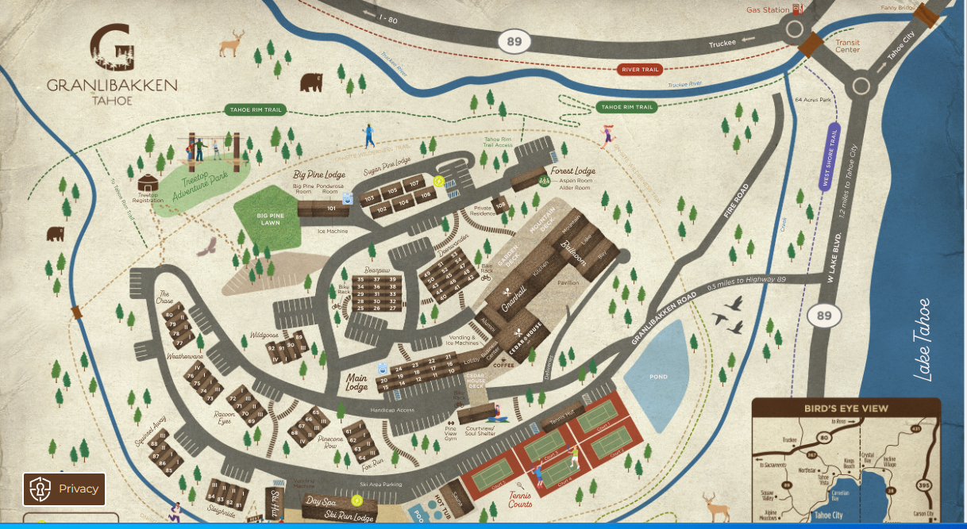

Hyatt Incline Village, September 5, 2024

<https://www.hyatt.com/hyatt-regency/en-US/tvllt-hyatt-regency-lake-tahoe-resort-spa-and-casino>

Luxury hotel located on the Nevada side of the lake, just 100 yards from the beach and about ¾ mile from the commercial district of Incline Village. More convenient to the Reno airport than the other 2 locations by driving over Mt. Rose. Google lists this as a 4-star hotel. Rooms are $199/night. $50/room resort fee reduced to $30/room. $29 parking fee reduced to $19. Facility rental fees waived with $25k F&B minimum. Meeting space would be right on the water (Lakeside A/B 3650 sf or B/C 4000 sf), in a facility that is across the street from the hotel. Space is potentially a bit tight because it is smaller than the other two sites, and we would do everything in the space. Talks, posters, and dining. There is attached outdoor space, but possibly not usable in April. AV provided by outside vendor (I should have a quote early next week). Poster boards are not available, and they recommended contacting UNR, although we could use the vendor recommended by the Everline. I’m checking with Nick B as to whether UNR has poster boards for rent. Only the earlier week available (March 30-Apr2). There is an on site 24 hour casino, but it’s off to the side of the lobby and you do not need to pass through to get anywhere. Closest ski areas are Diamond Peak (2 miles) and Mount Rose (11 miles). Numerous on site dining options, including a pub and café/convenience store. Numerous additional dining options in Incline Village.

Approximate price per attendee: $1930 + AV + Poster

Primary contact: Rockhey, KRISTIN [kristin.rockhey@hyatt.com](mailto:kristin.rockhey@hyatt.com)

AV: Landon Lerma <landon.lerma@encoreglobal.com>

